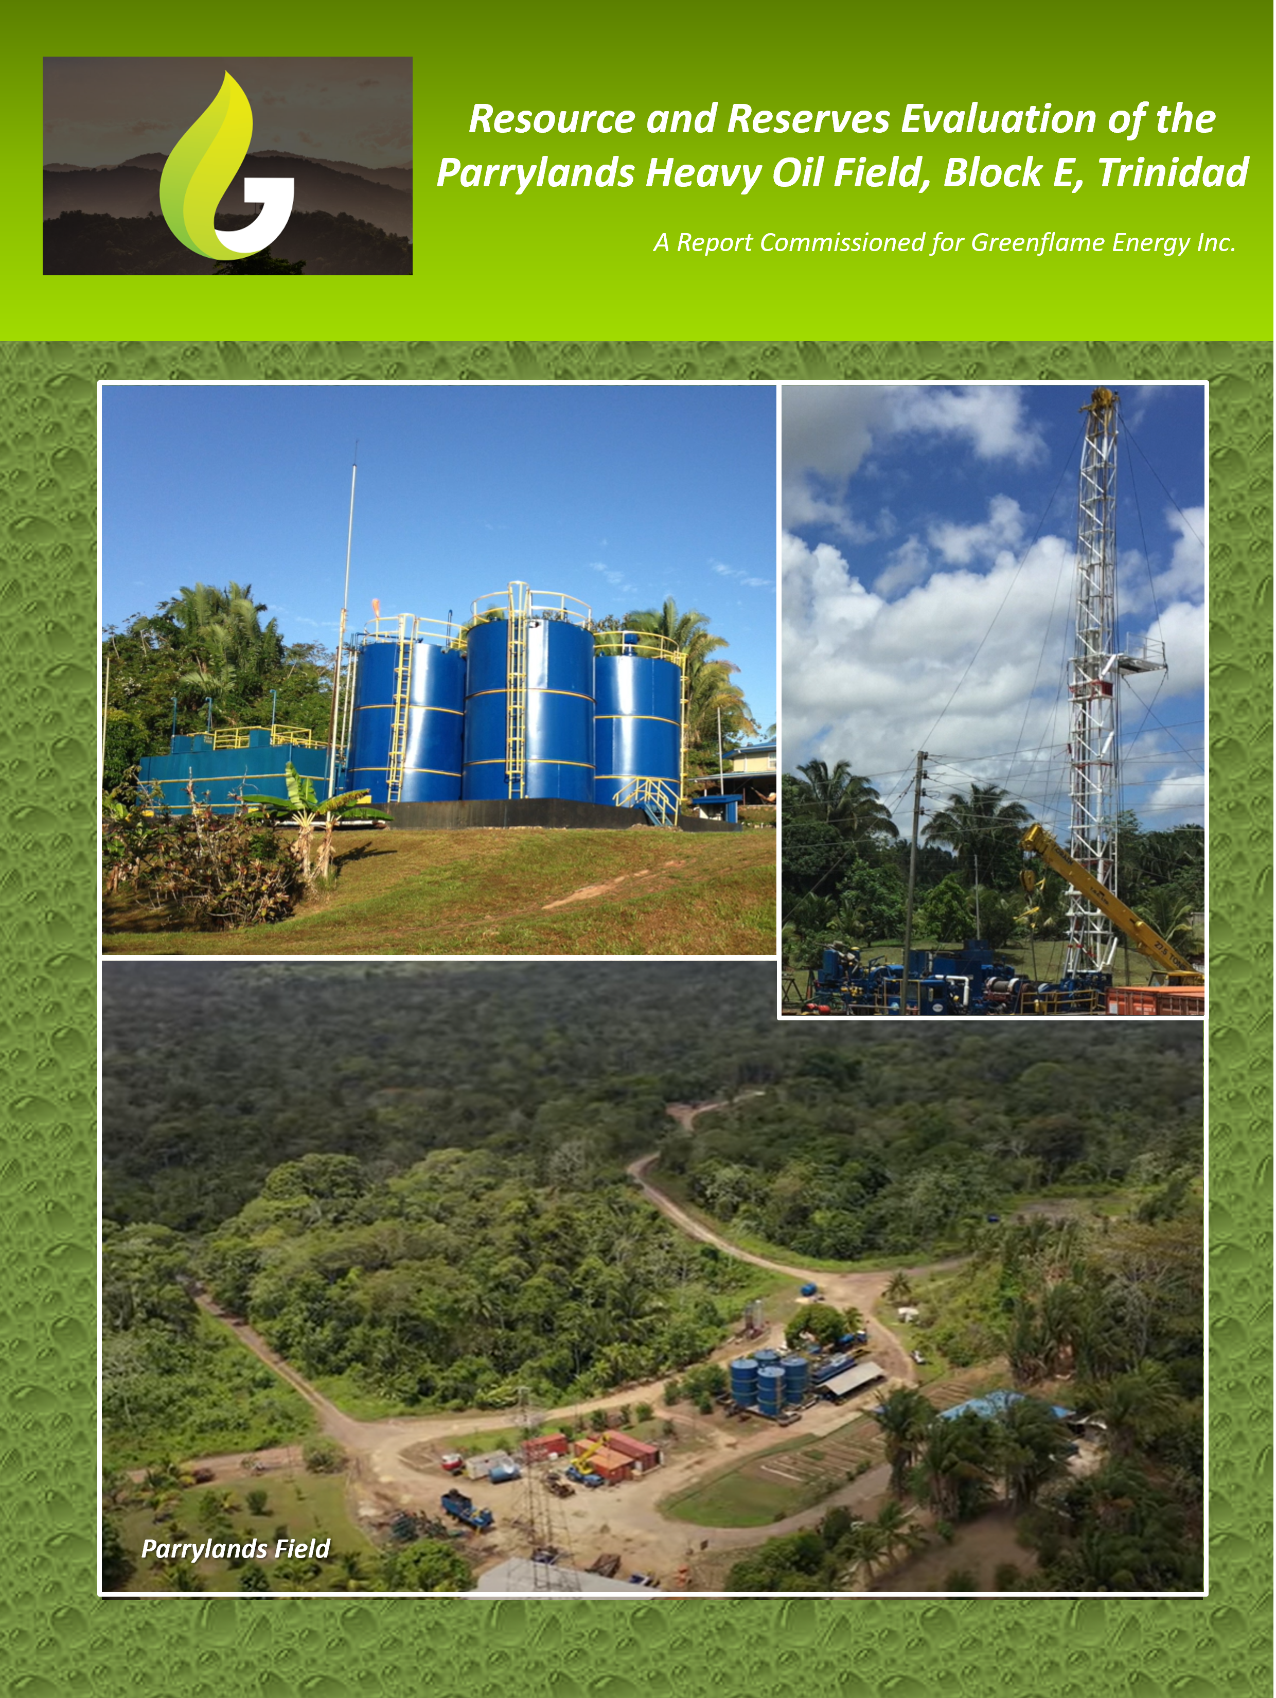

Resource and Reserves Evaluation of the Parrylands Heavy Oil field, Block E, Trinidad

Executive Summary

Greenflame Energy Inc is seeking an updated and upgraded heavy oil resource and reserves certification from Industry leading certifier Netherland Sewell and Associates for their proposed Heavy Oil development project in Block E of the Parrylands field, Trinidad. Located in the southern basin of Trinidad, the Parrylands Heavy Oil project consists of 110 wells that have been drilled and completed at a well spacing of generally 2.5 acres or less and that, upon investor capitalization, are ready for advanced EOR injection of cyclic superheated steam and flue gas (up to 100% CO₂) along with potential for CO₂ sequestration. Greenflame has a production sharing agreement with New Horizon Energy (NHE) the operator of the 744-acre Block E concession, the core productive acreage (net reservoir pay thickness >50’) of which is ~300 acres and estimated to contain 81 million barrels of original oil in place (OOIP).

Gaffney, Cline & Associates (GCA) certified 1, 2 & 3P Reserves and Contingent Resources for Block E in 2008 on the strength of demonstrated commercial analog production from the 30-acre Petrotrin/Texaco steam pilot adjacent to the western boundary of Block E and their own comprehensive simulation studies in Block E. Most potential for reserves growth in this updated certification will come from the northern half of the field where GCA’s previous classification was of Contingent Resources only because they regarded well spacing in the north to be too sparse to provide regular steam patterns and sufficient geological certainty, and NHE did not have a development plan for the north at the time. Since 2008, NHE has drilled an additional 32 wells in the north and Greenflame has provided an EOR program for exploitation of the heavy crude across the core productive acreage.

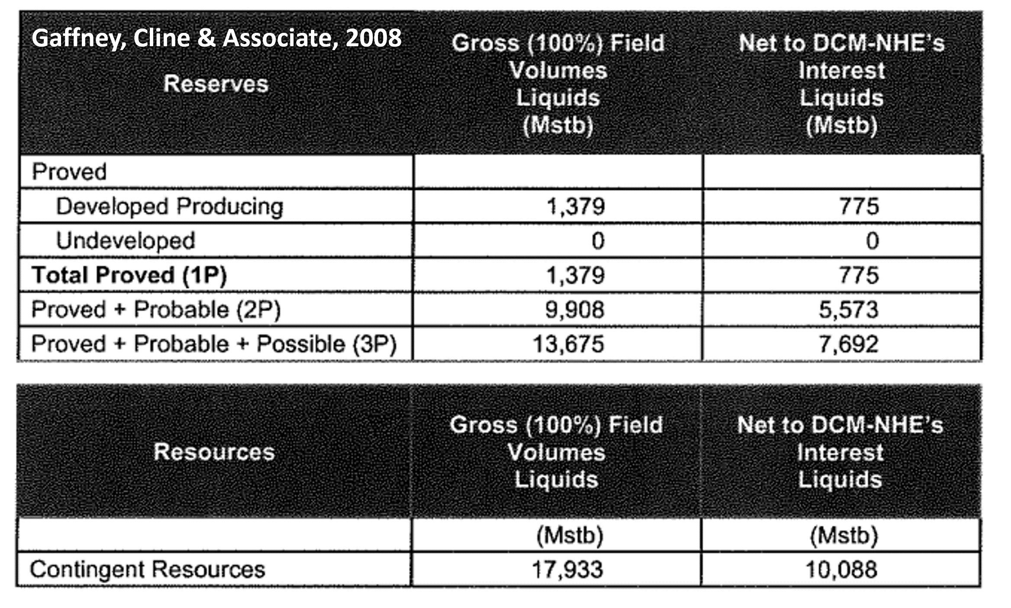
The principal heavy oil sandstone target in Block E is the Miocene-aged Forest Sandstone reservoir that typically varies from 50-250’ in net pay thickness, averages 34% porosity, has from 250-500 millidarcies permeability and averages 75% oil saturation. The reservoir sandstone is shallow, in the range of 900 to 1200’ and reservoir pressure is 500 psi. The crude oil is sweet containing <0.5% sulfur, heavy with gravity ranging from 10-19⁰ API and viscous at between 4,200-5000 centipoise (cP) at reservoir temperature of 99⁰F.

NHE and Greenflame have invested on the order of $20MM in new well drilling, well workovers, pump installations and improved reservoir management activities in Block E and the project is fully permitted. Infrastructure of power, roads, water and worker accommodations are all in place. The Block E concession is directly connected by a 15-mile pipeline to the local Petrotrin refinery, and the refinery is currently working at only 67% capacity. The concession is also 5 miles from the Atlantic LNG Plant with 7 MMSCF/day of pure CO₂ available for EOR and sequestration and Greenflame has signed an MOU for 350 MT/day of pure CO₂ to be used in the Parrylands area for carbon sequestration. This sequestered Carbon can be monetized in one of the voluntary carbon markets such as the Gold Standard that currently fetches on the order of $25/MT.

Block E of Parrylands field historically has cumulative production on the order of 680,000 barrels on cold production, less than 1% of the oil in place, and currently produces approximately 160 bopd on cold production from 30 wells. Deployment of Greenflame’s advanced EOR program, however, is a game-changer. Analog production from Petrotrin/Texaco’s 30-acre steam injection pilot recovered ~50% of the 6.1 MMBO of OOIP and modeling of Greenflame’s advanced technologies that inject all emissions into the reservoir effectively sequestering the carbon and simultaneously increasing oil production are projected to recover above 80% of the oil in place. The EOR opportunity has potential for a low cost, high netback and potentially carbon neutral production.

Table of Contents
Resource and Reserves Evaluation of the Parrylands Heavy Oil field, Block E, Trinidad 2
Executive Summary 2
Introduction 5
Geology of the Parrylands Field, Trinidad Southern Basin 6
Reservoir Stratigraphy at Parrylands 7
Parrylands Field Block E 8
Methodology of Original Oil in Place Calculation 11
Mapping Net Pay Thickness 11
Estimating Porosity and Oil Saturation 16
Assigning a Formation Volume Factor 16
Original Oil in Place Calculation of the Parrylands E Block, Trinidad 17
Production History 19
Analog Production in Neighboring Petrotrin/Texaco Steamflood Pilot 20
Synopsis of the Gaffney, Cline & Associates 2008 Reserves Certification at Block E Parrylands Field 21
GCA’s Reserve and Resource evaluation in Block E at Parrylands field 24
GCA’s economic assumptions 25
Reserve and Resource Classification (GCA, 2008) 28
Next Phase of Proposed Development at Block E, Parrylands Field 33
Advanced EOR Technology 34
Proposed Steam Injection Wells 37
Current Activities: Completed and In Progress 38
Economic Modeling and Assumptions 39
Doing Business in Trinidad & Tobago 42
Conclusions 43
References 44
Appendix 1: Audit Wells 45
Appendix 2: Calculation of OOIP based on Audited Net Pay Map 49
Appendix 3: Greenflame Trinidad & Tobago Investor Presentation 54

Introduction

Greenflame Energy Inc commissioned a report on the potential oil resources and reserves contained in the Block E concession of the Parrylands field, Trinidad. This report provides 1) an overview of the geology, reservoir and hydrocarbon characteristics of the target Forest Sandstone, 2) an audit of the net pay mapping and previous original oil in place (OOIP) estimates, 3) a synopsis of the 2008 resource and reserves certification by Gaffney, Cline & Associates (GCA), 4) a summary of drilling and completion operations in the field since GCA’s 2008 certification report, and 5) an outline of the next phase of development utilizing advanced Enhanced Oil Recovery (EOR) technologies at Block E, Parrylands field. Based on the substantial new drilling and operations since 2008 and the proposed advanced EOR development plan, Greenflame is seeking an updated and upgraded resource and reserves certification from Netherland Sewell and Associates (NSAI), and the objective of this report is to provide a reliable basis to support NSAI’s analysis.

Block E is a 744-acre concession within the Parrylands Heavy Oil field in the southern basin of Trinidad (figure 1) and is operated by New Horizons Exploration & Production Trinidad & Tobago Ltd (NHE) with whom Greenflame Energy Inc has a production sharing agreement. Parrylands field has 3 major Late Tertiary-aged producing horizons: Cruse, Forest and Morne L’enfer, but the principal target in Block E is the heavy oil in the Forest Sandstone reservoir. The Forest Sandstone is a high-quality reservoir that is up to 250’ in the centre of Block E, porosity ranges from 32-36% averaging 34% and permeability is in the range of 250-500 millidarcies (mD). Depth to the reservoir varies from 900-1200’. The hydrocarbons residing in the Forest reservoir are sweet containing <0.5% sulfur, heavy with gravity ranging from 10-19⁰ API and viscous at between 4,200-5000 centipoise (cP) at reservoir temperature of 99⁰F making them ideal for production by thermal techniques. Oil saturation is 75% and reservoir pressure is 500 psi. Currently the field produces approximately 160 bopd on cold production from 30 wells.

Cumulative production in Block E to date is on the order of 680,000 barrels by cold production and represents less than 1% recovery of the estimated 81 million barrels (MMBO) of oil in place. A 30-acre steam injection pilot just 660’ to the west of Block E implemented by Petrotrin/Texaco from 1981-2003 however, produced approximately 3 MMBO of the 6.1 MMBO in place for a recovery factor of 49% demonstrating the commercial producibility of the heavy crudes by thermal methods and justifying GCA to assign proved reserves for NHE in Block E in 2008. NHE has drilled and completed 32 new wells since the 2008 GCA reserves certification for a total of 110 completed wells at a well spacing in the core of the reservoir of generally 2.5 acres or less. In conjunction with Greenflame, the team has designed a new development program that includes advanced EOR methods of injecting superheated steam and flue gas (up to 100% CO₂) and that is modeled to recovery more than 80% of the OOIP with the added potential for substantial CO₂ sequestration. The wells are ready for implementation of the advanced EOR program upon raising investor capital and the economic evaluation promises a low cost, high netback and potentially carbon neutral oil production.

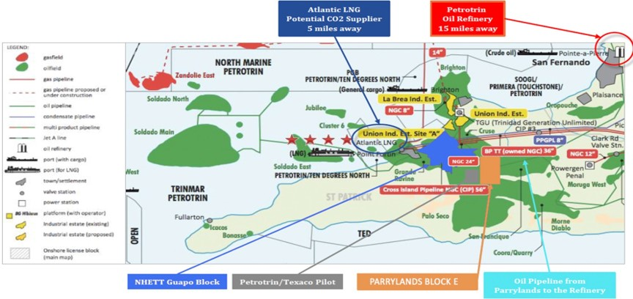
Figure 1. Location of Parrylands field Block and key infrastructure in South Trinidad.

Geology of the Parrylands Field, Trinidad Southern Basin

Late Tertiary-age sandstone reservoirs in the southern basin of Trinidad, just 11 miles off the coast of Venezuela, were discovered to contain abundant heavy oil accumulations from well drilling in 1866. The Parrylands portion of this discovery was first drilled in 1913 (figure 2) and slowly developed by Trinidad Oilfields Company and United British Oilfields of Trinidad. Texaco and Shell subsequently operated in parts of the area until the field was merged into Trinidad & Tobago’s National Oil Company, Petrotrin.

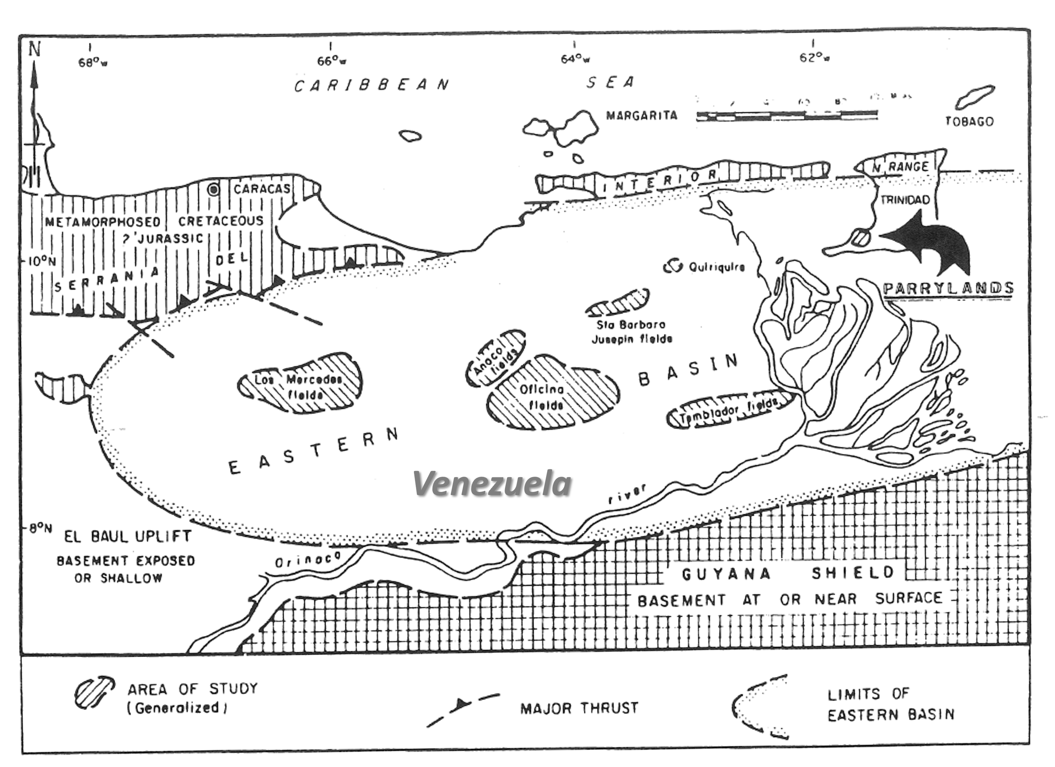
Figure 2. Location map of Parrylands field, Trinidad (modified after Salvador and Stainforth, 1968).

The Parrylands Oil Field lies on a regional trend of major oilfields in the southwestern peninsula of Trinidad and forms part of the Fyzabad group of pools consisting of various Miocene and younger sediment accumulations along an east-west axis of anticlines in the southern part of Trinidad (figure 3). Fyzabad Group of fields in the SW Peninsula of Trinidad lies north of the Los Bajos Fault, a major right lateral wrench fault that can be traced across the southwest of Trinidad in a direction 290⁰ – 110⁰. The horizontal displacement is on the order of six miles in a right lateral sense and the fault cuts and offsets all structures that it intersects. A subset of relief faults to the Los Bajos Fault run in a north-south orientation across the Parrylands field and act as east and west traps for the hydrocarbons. The Morne L’Enfer syncline also crosses the Parrylands field in an east-west direction creating a depositional centre for the Forest sands resulting in greater than 200’ thickness of reservoir quality sandstone and the vast reserves of the Forest Sand in the Parrylands Block E.

Reservoir Stratigraphy at Parrylands

The reservoir stratigraphy of the Parrylands field includes 3 major reservoirs: the Cruse Formation, the Forest Formation and the Morne L’Enfer Formation (figure 3). The Forest Formation is host to the heavy oils to be exploited by advanced cyclic steam technologies and is the subject of reserves certification in this report.

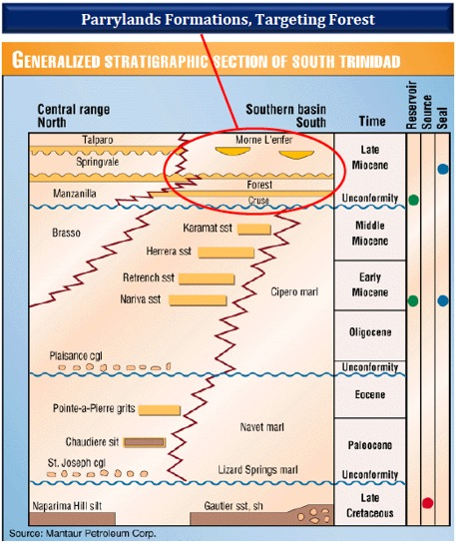
Figure 3. Stratigraphy of the oil fields of the Southern basin, Trinidad (from Mantaur Petroleum Corp). The heavy oils residing in the Forest Reservoirs are the target for recovery by advanced cyclic steam technologies.

Depositionally, the stratigraphic section at Parrylands represents a major Upper Miocene-Lower Pliocene-age regressive deltaic sequence unconformably overlying the massive sands (over 200’ thick) of the Cruse Formation. The lower Forest Clay was deposited on the Cruse unconformity surface and is the lithologic marker that defines the base of the Forest Formation. A succession of progradational sandstone units interpreted to be foreset bedding structures of a westward advancing delta system overlie the lower Forest Clay. Sandstone units in the middle of the progradational sequence are interpreted as barrier-bar deposits in a delta front environment and consist of a series of well sorted fine to very fine-grained sandstones and interbedded shales. The upper sandstone units are designated as the Forest “A” Sandstone and are interpreted as an amalgamation of north-northwest trending barrier bars, seven individual bars of which are defined in the Parrylands field area. The Forest Sandstone is capped by the Upper Forest Clay which is in turn conformably overlain by the Morne L’Enfer sequence that consists of generally massive sands with interbedded silty clays and lignites.

Parrylands Field Block E

Greenflame Energy Inc has a production sharing agreement with NHE in the “proven and producing” Block E designation of the Parrylands field initially, with potential to expand the operations across the Parrylands field area that has as many as 17,000 wells drilled historically. Block E covers an area of 744 acres (3 km²), has 110 wells drilled and completed and produces approximately 160 bopd from 30 active but unstimulated wells. NHE estimated Block E to contain 81 million of original oil in place (OOIP) with additional potential at depth (in the Cruse reservoirs) and is ready for immediate development utilizing advanced cyclic steam technology.

An unusual characteristic of Block E is the demonstrated gravity segregation of the crude oil in the field (Rambaran, 1987). Lighter crude of 16-19⁰ API gravity in the field is found on the crestal area of the anticline and 10-12⁰ API gravity crude on the lower flanks on the anticline. The higher API gravity crude on the crestal area can be produced commercially without the need for thermal technologies and can provide early cash flow prior to implementation of the advanced thermal methods. This benefits cold production in the northern part of Block E whilst the number of wells with superheated steam injection ramps up.

A type log from Well E94 is illustrated in figure 4 and shows the blocky gamma-ray log character of the Forest Sandstones. Oil-saturated section is readily identified on the resistivity log. NHE constructed a map of the net oil sands intersected in the Upper Forest Sandstone the Block E area (figure 5). Petrotrin/Texaco undertook a 30-acre pilot cyclic steam flood in the Upper Forest Sands from 1981-2003 in an area 660’ to the west of Parrylands Block E, 2,500’ west of Greenflame’s southern development area and 2,650’ from the northern development area (figure 5). Significantly, Petrotrin/Texaco recovered 3 million barrels (MMBO), or almost 50% of the original 6.1 million barrels of oil-in-place in their 30-acre pilot area.

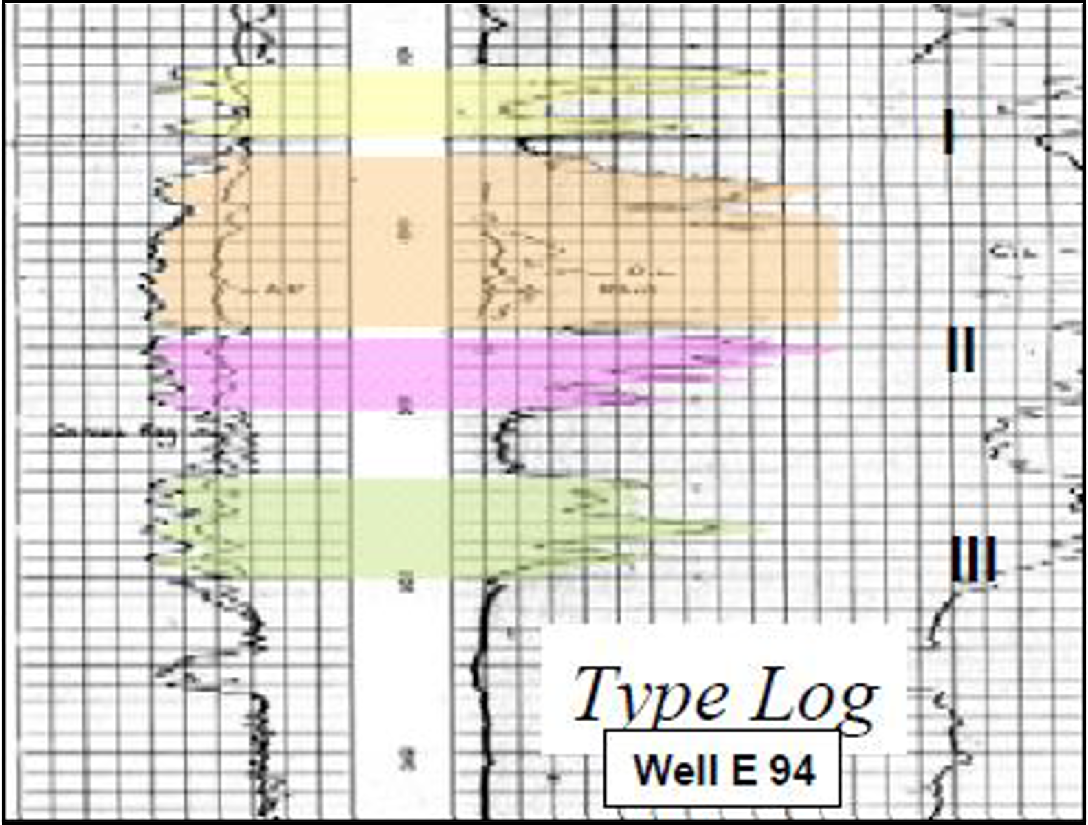
Figure 4. Type log (well E94) of the Upper Forest Sandstone at Parrylands Block E.

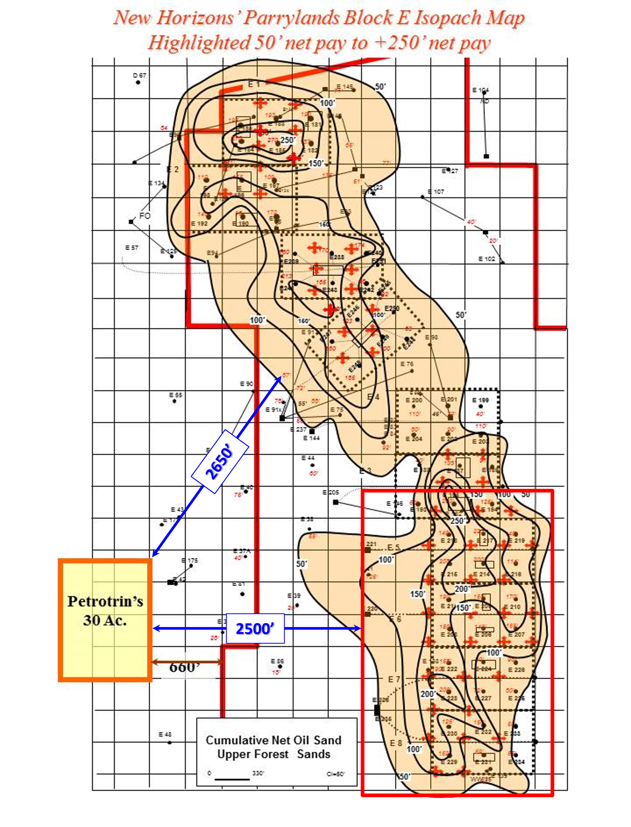
Figure 5. New Horizon’s cumulative net oil for the Upper Forest Sandstone at Parrylands Block E. The location of Petrotrin/Texaco’s 30-acre steam flood pilot and Greenflame’s northern and southern Development Areas is also illustrated.

Methodology of Original Oil in Place Calculation

Calculation of OOIP utilizes the following straightforward formula (see below) and requires a knowledge of the area and thickness of the heavy oil sand deposit, the porosity of the sand, and the percentage of oil saturation. In addition, there are two conversion factors that bring the oil-in-place calculation to standard conditions (or stock tank barrels). The first is a numerical constant, 7758, that converts acre-ft to stock tank barrels, and the second is the Formation Volume Factor (FVF), a dimensionless number that accounts for the change in oil volume from the reservoir to standard conditions.

The formula for this calculation is:
Where:
- OOIP = Original Oil in Place in barrels
- Area in acres
- Thickness in feet
- Porosity expressed as a decimal
- Oil saturation = 1- Sw (Water Saturation) expressed as a decimal
- Formation Volume Factor is FVF, a dimensionless number

Mapping Net Pay Thickness

NHE constructed a Cumulative Net Oil Sand map for the Forest A Sandstone based on logs provided by Petrotrin for Block E (figure 5). The Forest A Sandstones are blocky in gamma-ray log character and there is a clear demarcation between oil-saturated and water-saturated sands on the resistivity log (figure 6) and that intervals with a resistivity of less than 5 ohm.m is generally non-productive. As a result of the gamma-ray and resistivity log characters of the Forest A Sandstone, the audit in this report focused on defining net pay using the resistivity log.

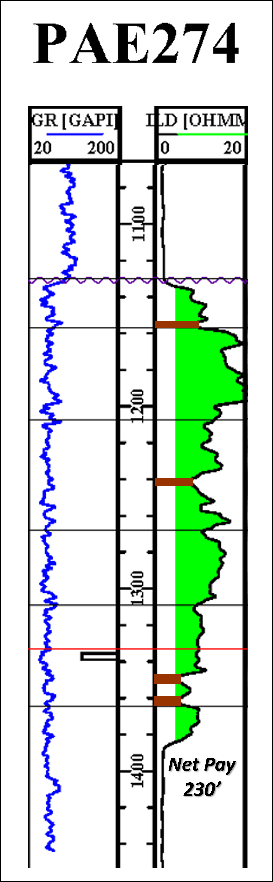
Figure 6. Calculation of net oil sandstone from geophysical well log data.

In total there were 30 wells provided by NHE from the southern half of Block E (figure 7 and Appendix 1) that were utilized for auditing the Net Pay Map. Once calculated, the net pay values were then plotted on the Upper Forest cumulative net oil map and compared with the surrounding contour values (figure 8).

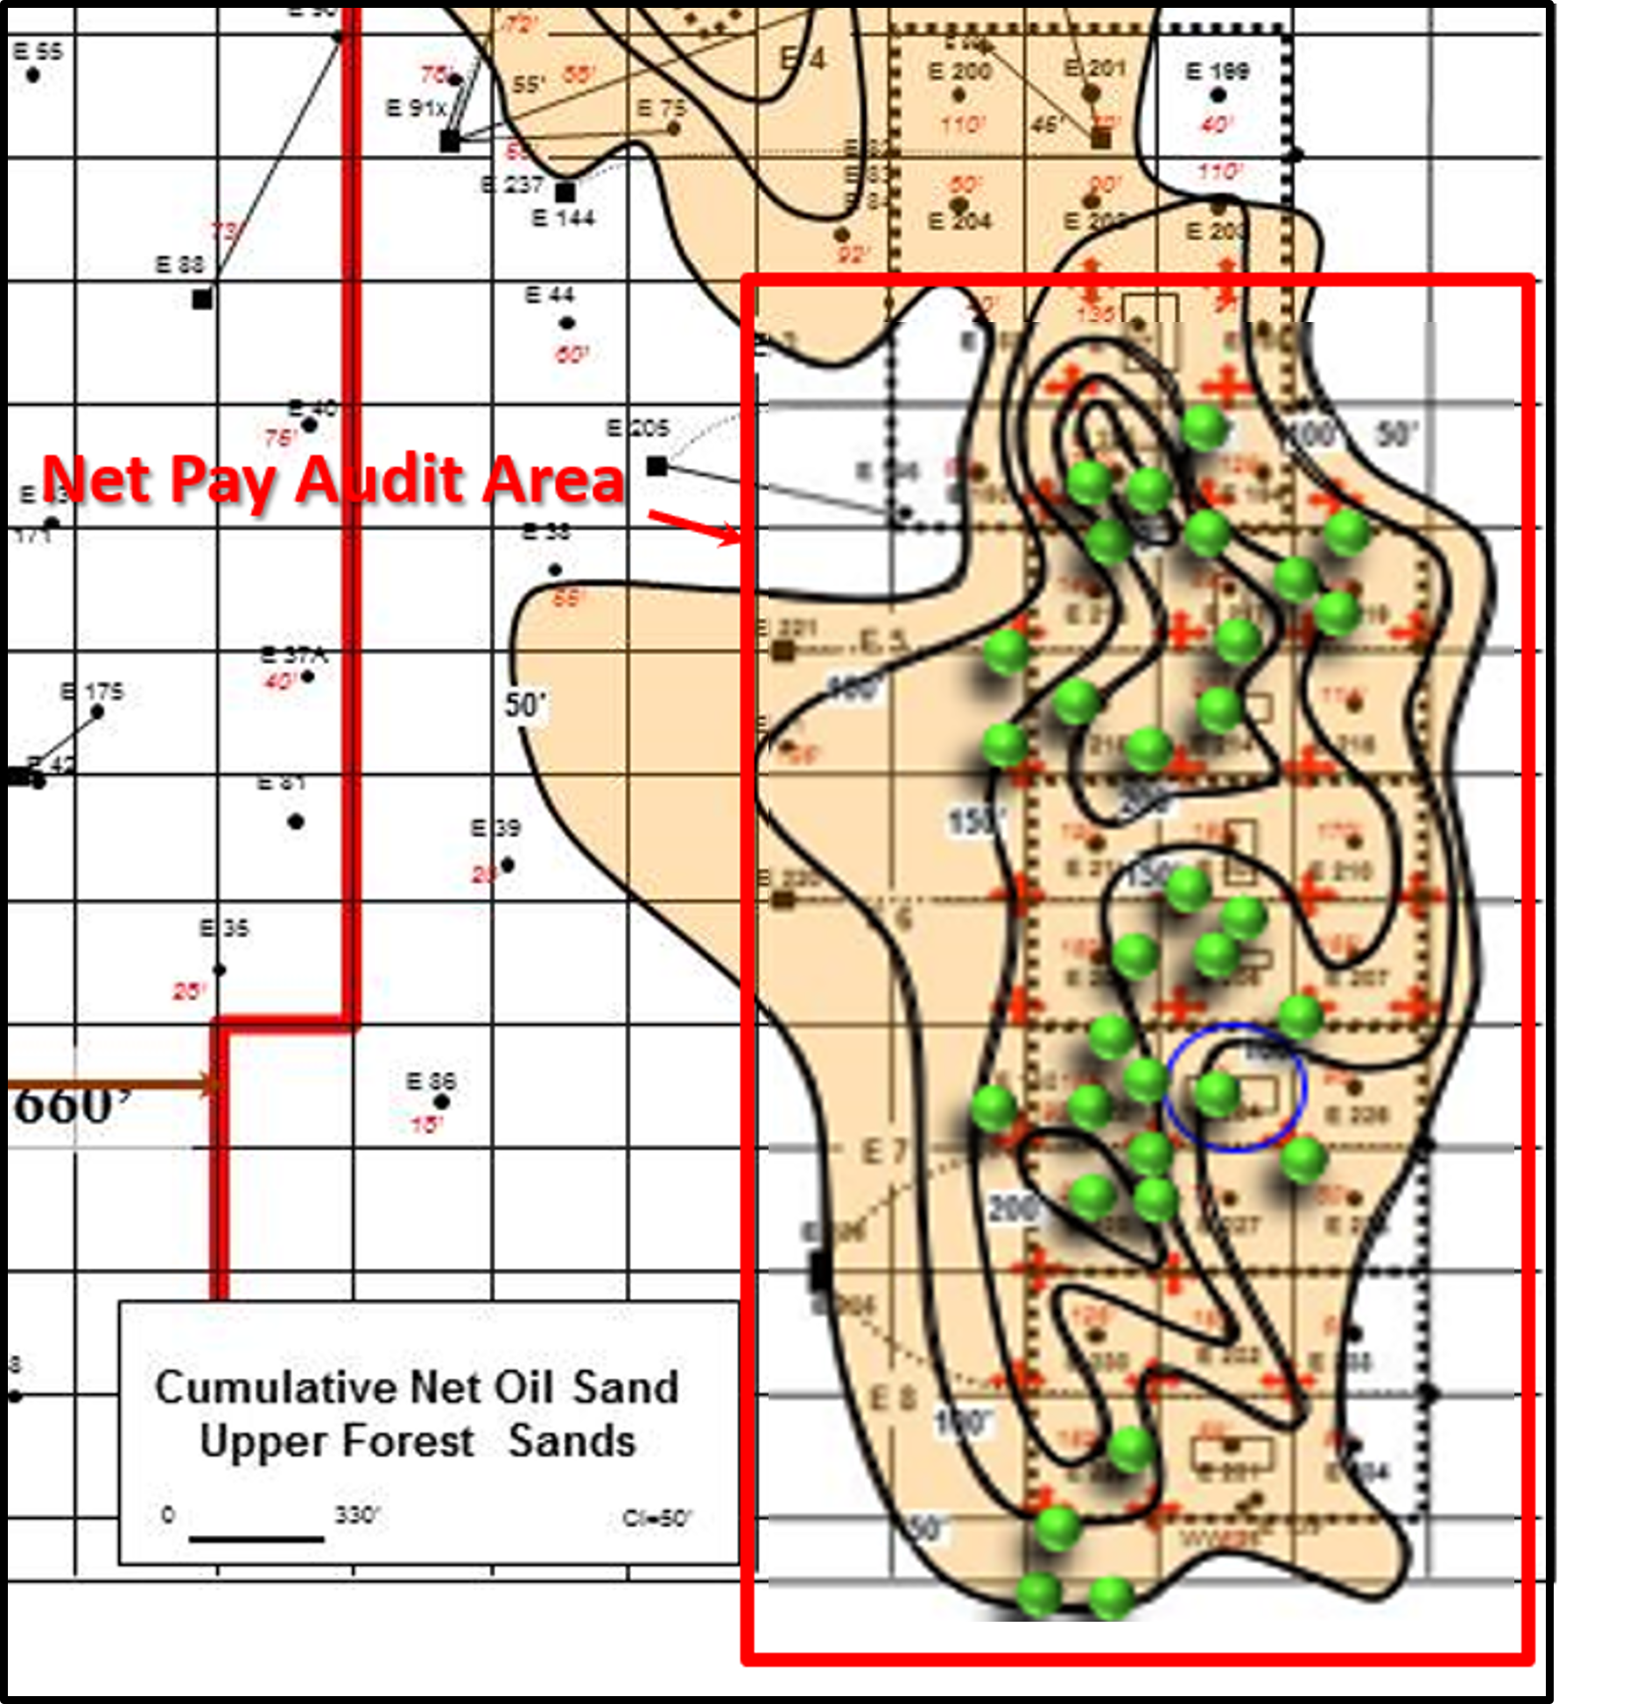
Figure 7. Net pay audit area consisting of 30 wells distributed across the southern half of Block E.

There is a very good relationship between the major sand-rich fairway defined by the contour trends and the net pay values calculated from the audit wells. There are, however, a couple of discrepancies between the audit wells and the net pay map both over and underestimating net pay thickness. The net pay calculated for Audit Well PAE 274 for example is 215’ but this well lies on the 150’ contour of the net pay map. Similarly, although in the opposite direction, net pay calculated for Audit Well PAE 291 is 118’ but this well lies between the 150’ and 200’ contour on the net pay map.

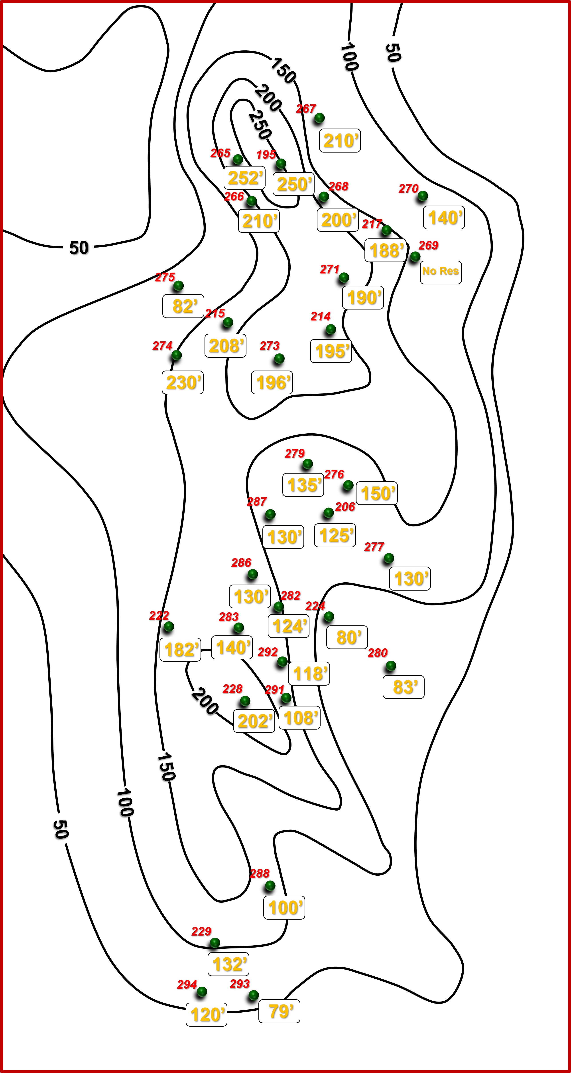
Figure 8. Comparison of net pay from the audit wells and NHE’s contoured net pay map.

A comparison of net pay calculated from the audit wells and net pay defined by the map contours was therefore compiled into a spreadsheet to quantify the difference between net pay on the map and net pay in the audit wells (table 1). Calculated net pay from 6 of the 30 audit wells matched/equalled the net pay map and a further 14 audit wells had net pay thicker than contoured on the map. In other words, 66% (20/30) of the audit wells had net pay thickness equal to or greater than the contoured net pay. Of the 10 audit wells that recorded less net pay thickness than the contoured map, three had a net pay thickness at least 90% of the value contoured on the map. Thus 77% of the audit wells had net pay either equal to, greater than, or within 10% of the contoured value on the net pay map. There were only 2 audit wells (PAE 275 and 291) that had anomalously low net pay thicknesses relative to the map, but more audit wells (PAE 267, 274, 294) that had anomalously high net pay thickness relative to the map.

Table 1. Compares the net pay values of the 30 audit wells and the net pay contours within which they plot. The correlation between the two values is quantified as a number and as a percentage.

The net pay map upon which the Upper Forest Sandstone reservoir volume was established and upon which the OOIP calculations depended, is regarded as reliable based on the results of the net pay audit. Whereas there are a couple of wells with anomalously low net pay values relative to the contoured map, there are more with much higher net pay values. Additionally, there is very good correlation in the major sand-rich fairway (where the bulk of the reservoir volume resides) of net pay in the audit wells and contoured values on the net pay map, indicating that it is more probable that the net pay map underestimates the reservoir volume than overestimates it.

Estimating Porosity and Oil Saturation

The porosity in a sandstone reservoir defines the space available for storing fluids (hydrocarbons or water) and can be referred to as the storage capacity of the reservoir. In a hydrocarbon-bearing reservoir, oil and water typically make up 100% of the fluids stored in the pore spaces. Therefore, if the water saturation (Sw) is 30%, then oil saturation (So) is 70%. The most reliable estimate of porosity and oil saturation of a reservoir rock is derived from laboratory analysis of core samples collected during exploration or appraisal drilling.

Gafney Cline & Associates (2008) undertook a detailed petrophysical analysis utilising well log and core data provided by NHE to determine porosity and water saturation of the Forest Sandstone reservoir at Parrylands field. GCA’s analysis included 98 wells that have gamma ray (GR), resistivity and porosity (density/neutron) logs. An additional 8 wells lacking porosity logs were also included in the analysis because they either had core data (for example PAE-162 and PAE-147) or helped define fluid contacts or/and reservoir continuity. Porosity values ranged from 32 to 36% yielding an average for oil volumetric calculations of 34%.

In calculating water saturation, GCA used the Simandoux shaly sand model. Input parameters for the model included a formation water salinity of 35,000 ppm, and cementation and saturation exponents of 1.8 and 2.0 respectively. Pay cutoffs were based on an effective porosity of greater than 20% and a water saturation of less than about 45%, which was derived from the Operator’s experience of little or no production in reservoir intervals where resistivity was less than 5 ohm.m. Average oil saturation of 75% (1-S_{w}) was derived from CGA’s analysis.

Assigning a Formation Volume Factor

Oil volume can change from the reservoir to standard conditions at surface and is considered in OOIP calculations by the assignment of a Formation Volume Factor. The main factors that cause the change in oil volume as a crude ascends from the reservoir to surface conditions are:
- oil loses mass because of a loss of dissolved gas
- oil shrinks slightly because of the reduction in temperature
- oil expands slightly because of the reduction in pressure

The Formation Volume Factor for the heavy oil in Parrylands Block E is considered insignificant (i.e., ~1) because the crude is heavy at 11-16º API gravity and has a low GOR of 50 Scf/Bbl. Moreover, the reservoirs generally lie in a depth range of 900-1200’.

Original Oil in Place Calculation of the Parrylands E Block, Trinidad

A grid of 2.5-acre blocks was overlain on the net pay map constructed by NHE (figure 9) and average net pay thickness was assigned within each block. Note that the 50’ net pay contour was defined as the cut-off for commercial steam flood operations in NHE’s mapping. The average porosity of 34% and oil saturation of 75% was then applied in each grid block along with a Formation Volume Factor of 1 to calculate the original oil in place (appendix 2). The total productive acres with net pay greater than 50’ is 299 acres in Block E. The average net pay thickness is 112’ giving a total OOIP of 70,781,337 barrels (appendix 2).

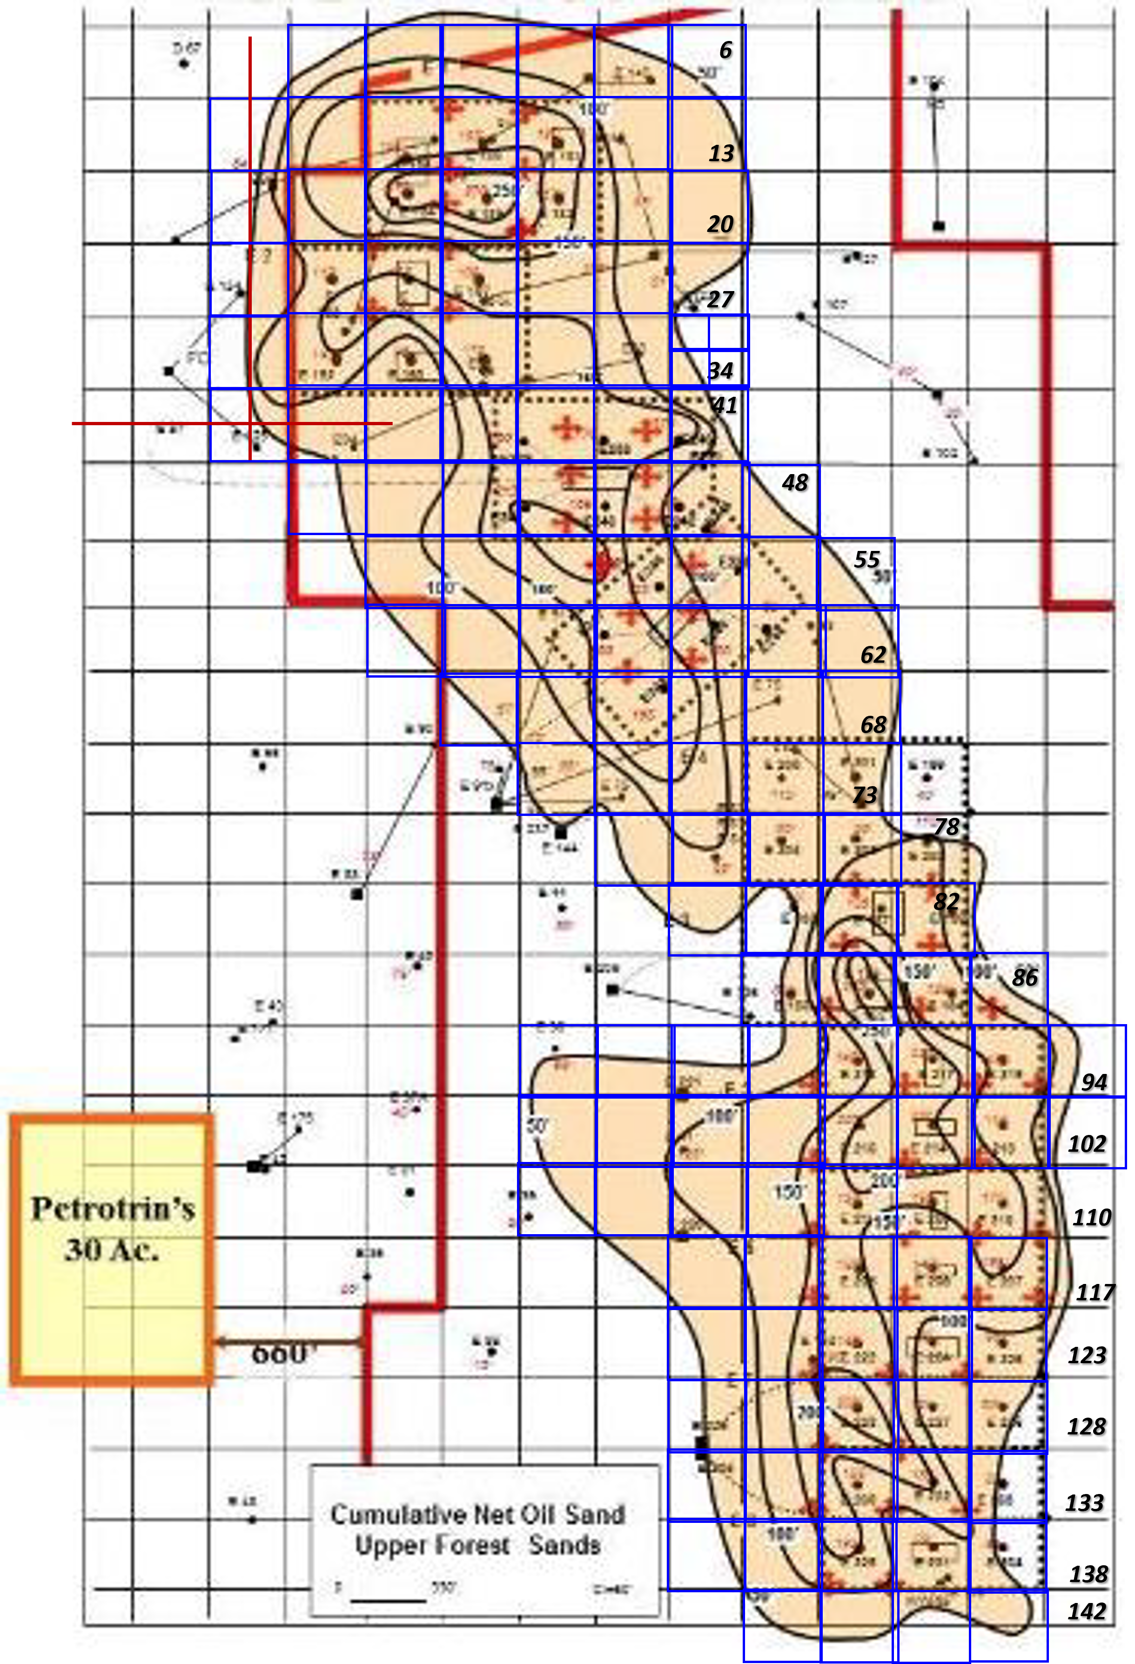
Figure 9. Net pay thickness map with 2.5 acre grid blocks superimposed for net pay calculations.

After auditing the net pay map by independently calculating net pay values in 30 densely spaced wells in the southern half of Block E it is concluded that the OOIP estimate of ~70 MMBO is potentially valid but too conservative for resource and reserves certifications purposes because NHE’s net pay map underestimates actual net pay thickness in many of the audit wells, on average by as much as 24%. Moreover, GCA estimated 81 MMBO of OOIP using the same porosity and oil saturation data in their comprehensive analysis of the Forest Reservoir in Block E. The major difference between GCA’s estimate of OOIP and that of this report is GCA’s calculated average net pay of 137’ within the lease boundary compared to 112’ of this report. Substituting 137’ for the 112’ parameter results in an OOIP of 81 MMBO (table 2).

Table 2. OOIP calculation when using a net pay thickness of 137’ as calculated by GCA (2008).

Production History

Block E of the Parrylands field was owned and operated by Petrotrin until the Year 2000 when NHE acquired operatorship. NHE embarked on a development program, drilling 60 new vertical and 10 horizontals wells between 2001 and 2004 to better define field limits. NHE initiated a steam injection project in 2004 using vertical wells as injectors and horizontal wells as producers but were forced to suspend the project after only two months because of unexpected steam breakthrough and increased water cut in the producing wells. NHE speculated that the unforeseen production response was caused by steam injection rates exceeding the fracture gradient and structural complexity of the field resulting in horizontal producers cutting across different fault blocks. NHE reoriented their development wells to vertical producers and injectors arranged in 5-spot patterns and in preparation for a vertical steam injection project, drilled an additional 24 vertical injectors and 28 vertical producers from 2006-2008 targeting the South-Central part of the field.

Field production rate in August 2008 was about 92 barrels of oil per day (BOPD) from the Forest Sandstone reservoir at depths ranging from 900 to 1,200 ft. According to Gaffney, Cline & Associates (GCA; 2008) productive acreage of the Forest Sandstone in Block E is on the order of 320 acres, the crude produced varies from 11⁰ API to 16⁰ API and flows at a viscosity of 4,200 cP at reservoir temperature. The average gas oil ratio (GOR) is 50 Scf/Bbl and the produced gas is used as lease fuel. Crude oil production is accompanied by very fine silt-like sand production which is an ongoing operational challenge resolved mostly by utilising progressing cavity pumps (PCP’s).

NHE has not released production data for the period 2008 till recently but current production is approximately 160 bopd from 30 unstimulated wells.

Analog Production in Neighboring Petrotrin/Texaco Steamflood Pilot

In 1981, Petrotrin/Texaco commenced a highly successful steam pilot project adjacent to Parrylands Block E just 660’ to the west of NHE’s concession boundary (figure 9). The geological and hydrocarbon characteristics of the 30-acre pilot area are virtually the same as in Block E. The productive reservoir in the steam pilot is the Forest Sandstone with an average 115’ of net oil pay, 32% porosity and permeability ranging from 250-500 millidarcies. Oil saturation is 75%, oil gravity is from 11-16⁰ API and oil viscosity is 4,200 cP at 99⁰F.

GCA (2008) constructed a graph of Petrotrin/Texaco’s pilot performance (figure 10) utilising historical production and steam injection data and reference material from Rambarran (1987). From 1981 till mid-1993, the pilot project produced 2.5 million barrels of the 6.1 million barrels of OOIP, representing a recovery factor of 41%. Note that NHE’s in-house review of Petrotrin’s production data recorded 3 million barrels of oil recovered over the life of the pilot, or a 49% recovery factor. The ratio of steam injected to oil produced was 4.2:1 (GCA, 2008) and is comfortably below the SOR (Steam injected to Oil produced Ratio) of 5 that is generally regarded as economically favorable for steam injection projects. The cost of steam generation (in terms of thermal equivalence) is enhanced in both the pilot area and Block E because the gas that accompanies oil production (GOR of 50 Scf/Bbl) is used as lease fuel.

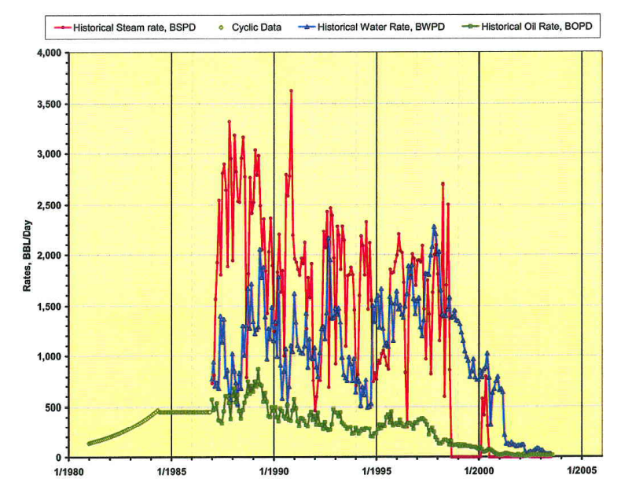
Figure 10. Petrotrin/Texaco’s pilot production performance.

The pilot utilized thermal steam enhanced oil recovery methods to enhance production and stimulate the reservoir. 5-spot well patterns within 16 wells on 150’ spacing was utilized. Management’s experience has demonstrated that steam injection can be approximately 3 times more expensive than Hot Flue Gas EOR. Pre-thermal pilot production was approximately 25 bopd; post thermal pilot production reached 500 bopd in Year 4. Peak production: 750 bopd in Year 8, produced 3 million barrels in 20 years. Approximate recovery was 50% of OOIP.

Synopsis of the Gaffney, Cline & Associates 2008 Reserves Certification at Block E Parrylands Field

GCA prepared a reserves certification report for NHE in 2008. NHE provided GCA with a comprehensive data base of digital well information from about 174 wells in and around the Parrylands area including well logs, core measurements, production records and maps, most of which were organized in a PETRA project. GCA critically reviewed the digital well data and generated their own interpretation of some 123 wells that involved modifications to the stratigraphic correlations as well as improvement to the fault patterns present in the field. GCA also constructed a comprehensive petrophysical model that addressed porosity, water saturation, permeability characteristics (vertical and horizontal) and hydrocarbon distribution.

From their analysis GCA observed that the entire field cannot be represented by a single fluid contact because oil-water contacts or lowest known oil levels were different across different fault blocks, and localised occurrences of water adjacent to, and trapped by, certain faults represented “Perched” water not representative of the oil water contact in such fault blocks.

GCA created a three-dimensional model in Petrel consisting of six horizons (five sand tops and one reservoir base) along with the fault plane interpretations and the lease boundary with a grid size defined in IJ spacing of 150ft x 150ft and K layering averaging 4 ft, which resulted in 167,462 total cells in the full field geological model (figure 11).

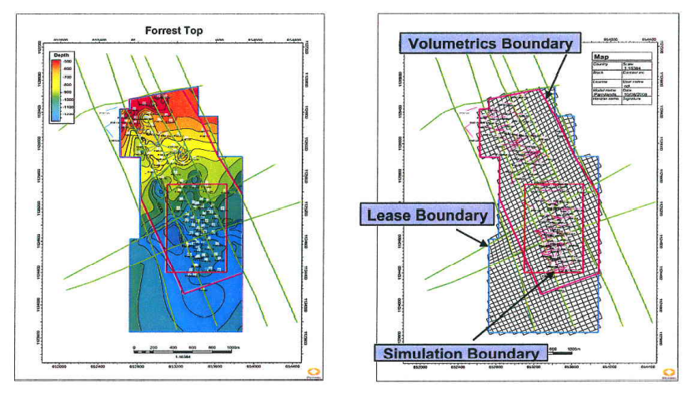
Figure 11. Schematic of GCA’s structure and model boundaries at Block E of Parrylands field.

The Petrel model was populated with porosity, clay volume, water saturation and permeability data using the deterministic mapping methodology of Krigging and Co-Krigging, and finally oil-water contacts were identified and input for volumetric calculations. Most production is at low water cut, and water production is observed in the vicinity of the oil-water contact.

The original oil in place estimate within the lease boundary from GCA’s Petrel model is 81 MMBbl. GCA also estimated a subset volume for an area of the lease where existing wells are to be steam stimulated (see Simulation Boundary on figure 11) of 34 MMBbl in place.

GCA followed up the Petrel model with a Dynamic Reservoir Simulation Model utilising CMG STARS software. The central-south area of Block E where twenty-four (24) injectors were recently completed was selected as the steaming area for simulation. In addition to the reservoir parameters mapped in the Petrel model, one PVT region and one rock type were used in the dynamic model. Oil viscosity was estimated from the closely adjacent Petrotrin/Texaco Pilot Area.

Details of upscaling modelling parameters and Dynamic Model construction are outlined in GCA’s 2008 reserves report. In the central-south part of Block E, the dynamic model matched historical data for both production rate and well bottom-hole pressure, providing high confidence for the steaming study in the area (figure 12) although the history match for the whole field was not good because of unresolved problems of well locations or well correlations in the northern part of the field (figure 13).

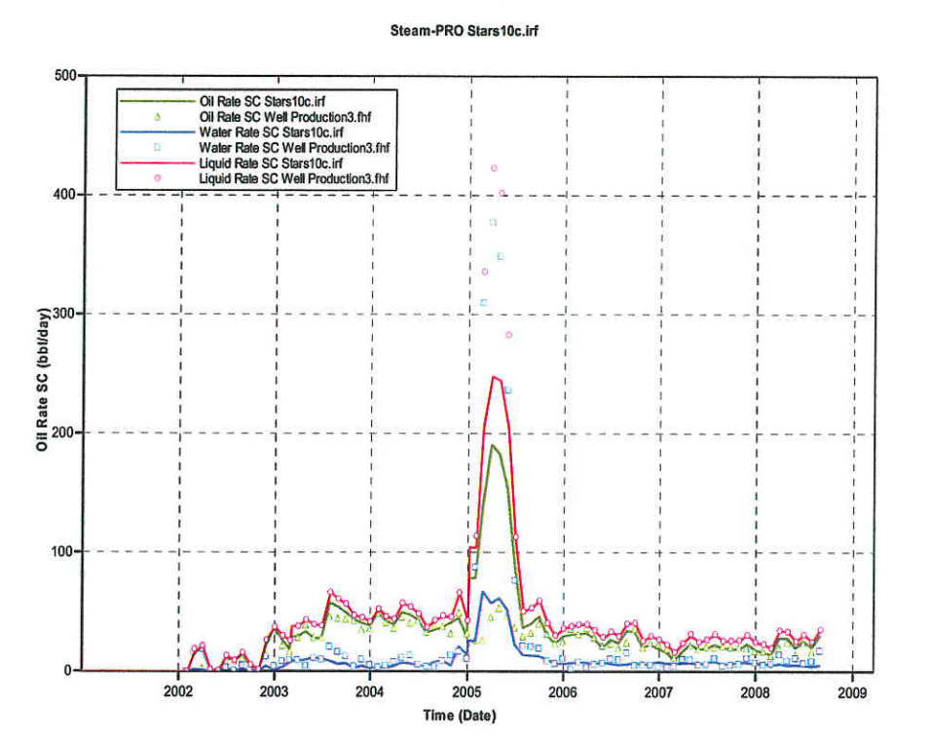
Figure 12. History match for the Steam Area in the south-central area of Block E of Parrylands field.
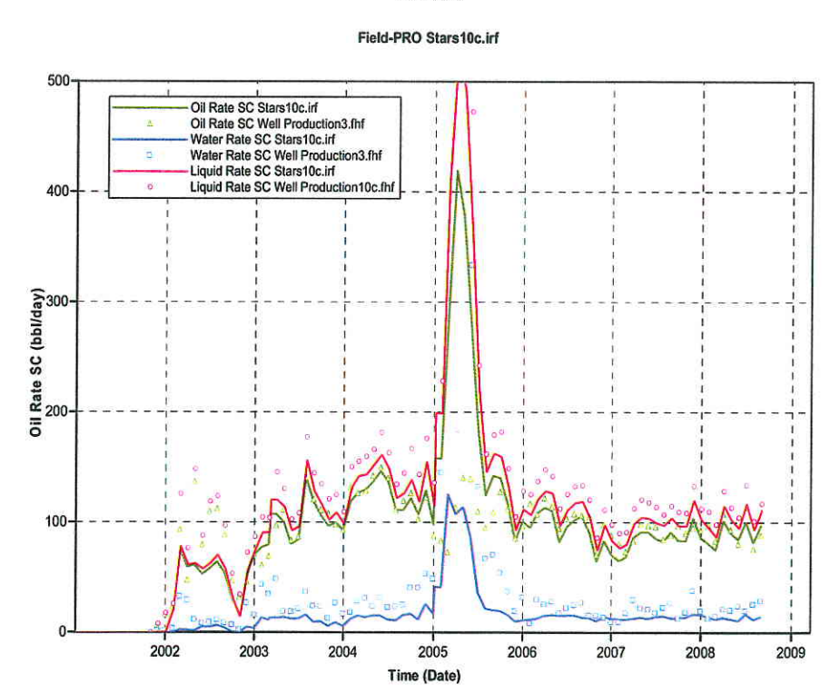
Figure 13. History match for the Whole Field, Block E of Parrylands field.

GCA undertook many production simulation runs and made several production projections as well as outlining key constraints on steam injection rates, identifying that the capacity of the reservoir to accept steam is an important issue to consider. GCA also offered many operational solutions to optimize incremental recovery however and identified the orientation of steam injectors/producers (preferentially north-south oriented), capping injection pressures to avoid exceeding fracture gradients and undertake thermal surveillance to monitor steam chest development and adjust timing of completions and infill drilling.

GCA also created an analytical model based on the Myhill-Stegemeier (M-S) correlation to investigate the potential production performance of the remaining reservoir area of Block E outside the south-central simulation area. CGA achieved a good correlation and concluded that the indicative recovery projections for the remainder of the field matched that of the simulated south-central area (GCA, 2008, p. 20). The oil rate projection for southern area of Block E is illustrated in figure 14 and the cumulative production forecast in figure 15. Similarly, the oil rate projection for northern area of Block E is illustrated in figure 16 and the cumulative production forecast in figure 17.

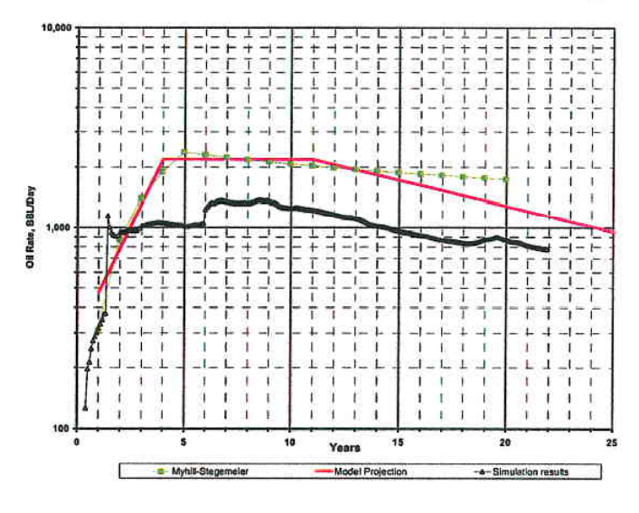
Figure 14. Oil rate projection for the southern area of Block E (GCA, 2008, p. 21).

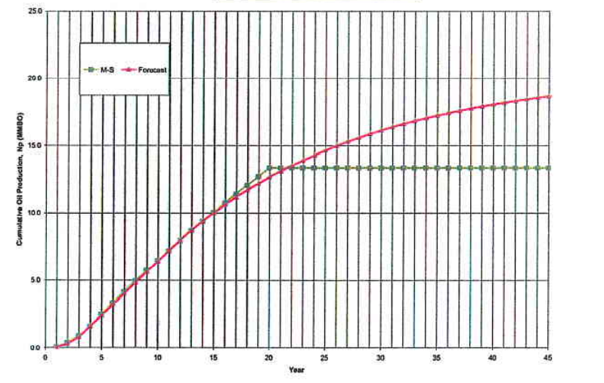
Figure 15. Cumulative production forecast for the southern area of Block E (GCA, 2008, p. 21).

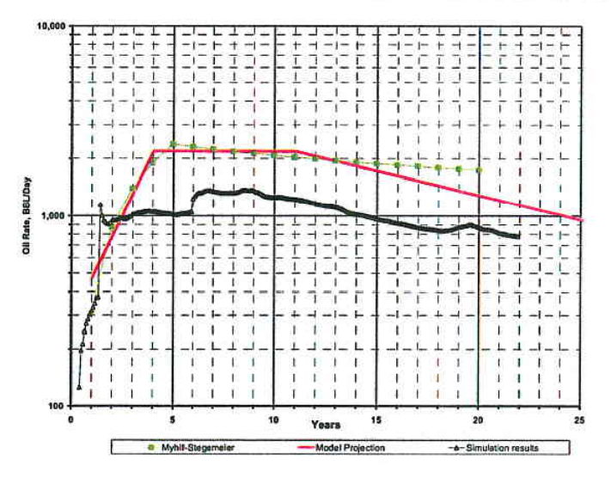
Figure 16. Oil rate projection for the north area of Block E (GCA, 2008, p. 21).

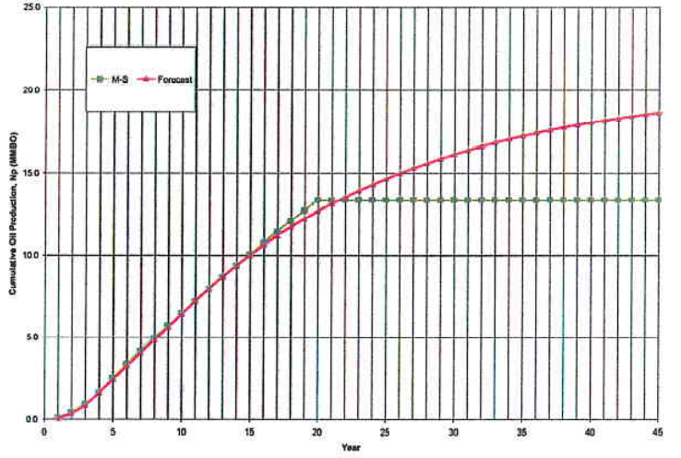
Figure 17. Cumulative production forecast for the north area of Block E (GCA, 2008, p. 21).

GCA’s Reserve and Resource evaluation in Block E at Parrylands field

The dense well control in Parrylands Block E provides confidence of reservoir quality, distribution and thickness of the Forest Sandstone reservoir. There is frequent faulting and some database-related issues regarding well path description in the northern part of Block E, but the sporadic occurrence of these well record inconsistencies does not present a significant risk for in place volume calculation (GCA, 2008). The dense vertical well flood pattern planned for the steam injection implementation will mitigate the impact of the faulting and any stratigraphic complexity.

The Petrotrin/Texaco steam pilot that is located just 660’ to the west of the Block E concession boundary and that produced from almost identical reservoir and hydrocarbon characteristics as in Block E is a direct production analog enabling confident prediction of a similar production performance in the south-central steam area of Block E. The Petrotrin/Texaco steam pilot produced 3 MMBO of the 6.1 MMBO in place at a recovery factor of 49% and reached a peak production rate of 750 bopd from 16 wells, a 30-fold production increase from the 25 bopd pre-steam cold production.

In Block E, individual well productivity has been established through cold production over the years and the wells are equipped with progressing cavity pumps that are capable of operating with sand production. The sand production is limited and not expected to increase with steam injection because high temperatures tend to stabilize fines and the lowered oil viscosity reduces the drag caused by oil flow. The expected steam oil ratios based on the simulations are relatively low at a 3-4:1 range and could be potentially higher without diminishing the chances of commercial success. Fuel costs in this project are lowered because gas produced along with the oil (GOR is 50 Scf/Bbl) can be used as lease fuel in steam generation.

GCA’s Economic Assumptions

The WTI oil price index was used as a benchmark for oil price reference. The historical oil sale prices in Block E have provided a basis to calculate the oil price differential to the WTI index. In the final reserve estimate (table 3), GCA used the WTI forward strip as of December 31, 2008, as the basis for forward price projection.

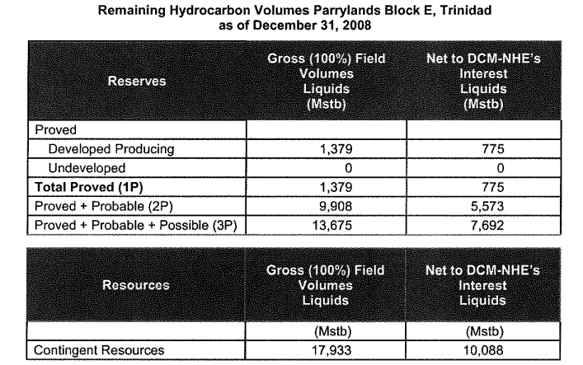
Table 3. Remaining hydrocarbon volume Parrylands Block E, Trinidad as of December 31, 2008.

At the time of GCA’s report writing in December 2008 the average oil price (WTI) for the preceding 12 months was US$100/Bbl. Recognizing that the oil prices were in a downward trend during the last 5 months, a lower price (US$48/Bbl) was used as a price sensitivity in a flat projection that was close to the prevailing prices at the time of the study. Table 4 below illustrates that the difference in oil pricing affects the 1P category more than the other reserve and resource categories.

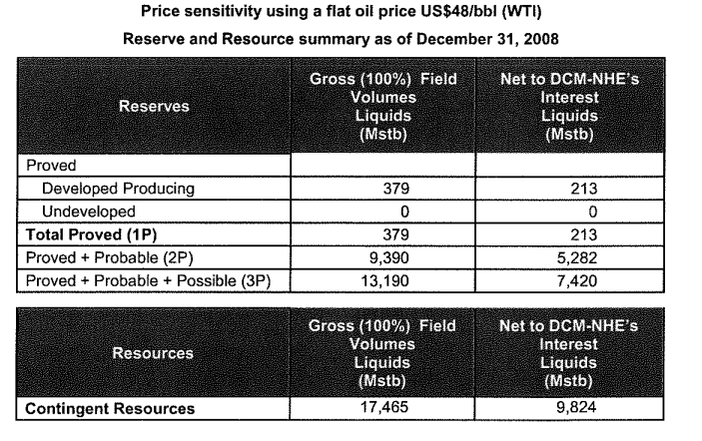Table 4. Price sensitivity using a flat oil price US$48/bbl (WTI). Reserve and Resource summary as of December 31, 2008.

GCA (2008) concluded that at the US$48/Bbl WTI price level it is economic to produce the field with primary operations (1P case). Considering pricing sensitivities, it would be uneconomic to produce the field in these conditions at a (US$40/Bbl) WTI price, although the projected reserves of the thermal cases (2P and 3P) would not be affected much because the projected incremental oil production is sufficient to compensate the cost of thermal development and the respective operating expenses.

The CAPEX requirements to drill 25 new injection wells is based on NHE’s estimates of US$4.2 million (US$0.17 million per well). NHE owns an oil rig that was originally outfitted in Trinidad and was used by NHE to drill the 24 new injectors. NHE provided a cost estimate for the uphole recompletion at US$21,000 per well. A more conservative value of US$25,000 per well was adopted by GCA.

There will be no additional CAPEX costs for steam generation. There are two units in operation that have a 5,500 BSPD steam generation capacity, a standard 50,000 MMBTU/hr unit and a smaller unit rated at 20,000 MMBTU/hr. A new 50 MMBTU/hr unit will be required for the expansion of the project to the South area. The cost estimate given by NHE was US$600,000 for refurbishing an old generator. GCA used a figure of US$1,300,000 under the more conservative assumption for procurement from North America (US or Canada) and shipment to Trinidad.

The OPEX estimates are based on present costs that are about US$70,000/month. These costs are covering operations except gas fuel used from steam generation. With the addition of new wells, this cost is assumed to increase proportionally, and a 30% increase is expected to occur by the initiation of thermal operations to account for increased field and surveillance activity. The steam generation cost is mainly driven by the price for fuel gas and the cost of water treatment. The fuel gas cost is provided from existing agreements between NHE and Petrotrin which is US$1.50/Mcf escalated at 1% pa. It is estimated that about 0.5 Mcf will be required to produce 1.0 Bbl of steam. The water treatment cost is estimated at US$0.30/Bbl based on typical steam operation costs.

Reserve and Resource Classification (GCA, 2008)

The following section on reserve and resource classification is reproduced almost verbatim from GCA’s 2008 report with modifications made only for new operational work since undertaken by NHE. The existing cold production is well established at Block E and provides a basis for allocation of certain volumes as Proved Reserve. The decline observed and expected is low given the large oil in place and the low-pressure drawdown experienced. The projection was made using the full field simulation model up to 2031. It was extrapolated beyond that using an exponential decline. Higher oil production rates could be possible by increasing pump speed and lowering the bottom-hole pressure, but that would carry the potential risk of increased sand production and increased water cut by water coning. GCA did not attribute any reserve estimates to the shut-in wells in 2008 as proved not producing or proved undeveloped. NHE has drilled an additional 32 wells in the north part of the field since 2008 (figure 18) and produced an estimated 500,000 barrels on cold production from the northern half of Block E (Greg Boyles, Founder and CEO of NHE, personal communication, July 2022).

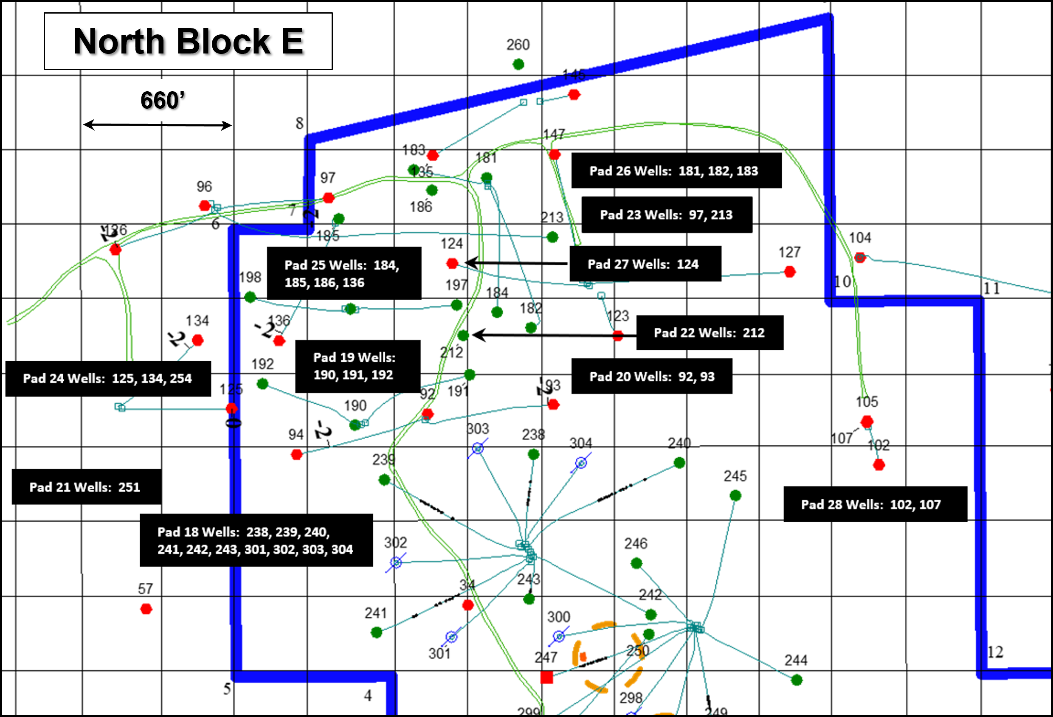
Figure 18. Wells drilled by New Horizon since 2008 in the north part of Block E Parrylands field.

The implementation of the steam injection using vertical patterns has a high likelihood to be successful as the methodology has already been demonstrated in the Petrotrin pilot. The analytical and numerical models confirm these expectations and provide a basis for a best estimate that is considered as the 2P scenario. That is based on the simulation results of simulation Case 8 (GCA, 2008, p. 18) that have been extrapolated beyond 2031 up to 2051 using exponential decline. A fair geological description and incorporation of core and fluid analysis and the results of sensitivities that involve other parameters contribute to the reasonableness of this type of estimate. As there are no established records that would allow a history match of the thermal model, this estimate would not represent a level of certainty that could be characterized as proved.

A further expansion of the existing patterns into the surrounding area in the south provides the basis for a 3P estimate. In that case, the analytical tool that was tuned to both the historical pilot performance data and the simulation data provides a credible basis for this higher outcome estimate.

An expansion of the thermal development to the northern part of the field is more dependent on formulating the development plan required to drill the necessary wells. A number of the existing producers can be used as take points, but certainly more producers will be needed to provide regular patterns. The geological description in that part of the Block is more convoluted and newer well data would contribute to improving the mapping quality. Therefore, the thermal expansion to the Northern part of the field would result to additional recoverable volumes that are classified for the time being as Contingent Resources. The main contingency is the formulation of a development plan in this area and the improvement of geological mapping.

Next Phase of Proposed Development at Block E, Parrylands Field

Greenflame Energy Inc has a production sharing agreement with NHE and is embarking on an aggressive development program implementing new Enhanced Oil Recovery (EOR) technologies to exploit the 81 MMBO in place in Block E of the Parrylands field. The field historically has cumulative production on the order of 680,000 barrels on cold production, less than 1% of the oil in place, and currently produces approximately 160 bopd on cold production from 30 wells. There are 110 existing wells drilled in the concession that are ready for immediate implementation of the planned EOR program and the project is fully permitted. The base huff and puff schedule is outlined in the accompanying excel spreadsheet “Trinidad Economic Model”. Infrastructure of power, roads, water and worker accommodations are all in place. There is a direct pipeline from the Block E concession to the local Petrotrin refinery located 15 miles from the property (figure 1) and the refinery is currently working at only 67% capacity. The concession is also 5 miles from the Atlantic LNG Plant with 7 MMSCF/day of pure CO₂ available for EOR and sequestration. There is a strong in-Country operating team with uninterrupted business continuity for almost 20 years with local knowledge as well as government and regulatory relations at multiple layers.

Trinidad & Tobago (T&T) is the 4th largest per capita carbon emitter in the world at 25.4 MT per person/annum. The vast majority of T&T’s CO₂ emissions comes from the LNG plants. The CO₂ is essentially Pure CO₂ which means there are no capture costs. The potential for CO₂ sequestration in Greenflame’s EOR program is very large. Stratigraphic formations beneath the Forest Sandstone reservoirs can sequester significant volumes of CO₂. The underlying San Fernando Formation has reef limestones and the sandstones in the Cipero Formation can be 1000’ thick (figure 3). CO₂ not used for EOR operations will be permanently sequestered in these deeper formations. The project can be monetized in the Voluntary Carbon Credit Market, the price of which can be $25/MT or higher. T&T has over 17,000 wellbores in the onshore sector and the potential upside from carbon sequestration could rival the value of the oil produced.

Greenflame has signed an MOU for 350 MT/day of pure CO₂ to be used in the Parrylands area for carbon sequestration which will reduce the per capita emissions of T&T by a full 4%. This sequestered Carbon can be monetized in one of the voluntary carbon markets such as the Gold Standard.

The EOR opportunity has potential for a low cost, high netback and potentially carbon neutral production. Greenflame’s advanced technologies inject all emissions into the reservoir effectively sequestering the carbon and simultaneously increasing oil production. The project could become carbon negative once the CO₂ pipeline is operational. Analog production from the adjacent Petrotrin/Texaco steam injection program recovered ~50% of the in-place oil. Greenflame’s advanced technologies are projected to recover above 80% of the oil in place.

The DOE estimates that each ton of sequestered CO₂ will produce 3.3 bbls of additional oil, or over 1,000 BOPD for the Parrylands project (appendix 3, p. 60). The Company’s proprietary EOR methods include heating the reservoir in total, enhancing the overall recovery and production time in a more cost-effective manner than thermal steam injection. Company conservatively estimates 50+% recovery while modelling studies yield rates >80%.

Advanced EOR Technology

Greenflame will deploy 3 key technologies in Parrylands Block E EOR program. The first is the AVS Superheated CO₂ Steam Technology (figure 19) for which Greenflame has secured a Trinidad license. The second is CO₂ flooding and the third is SMART PUMPER.

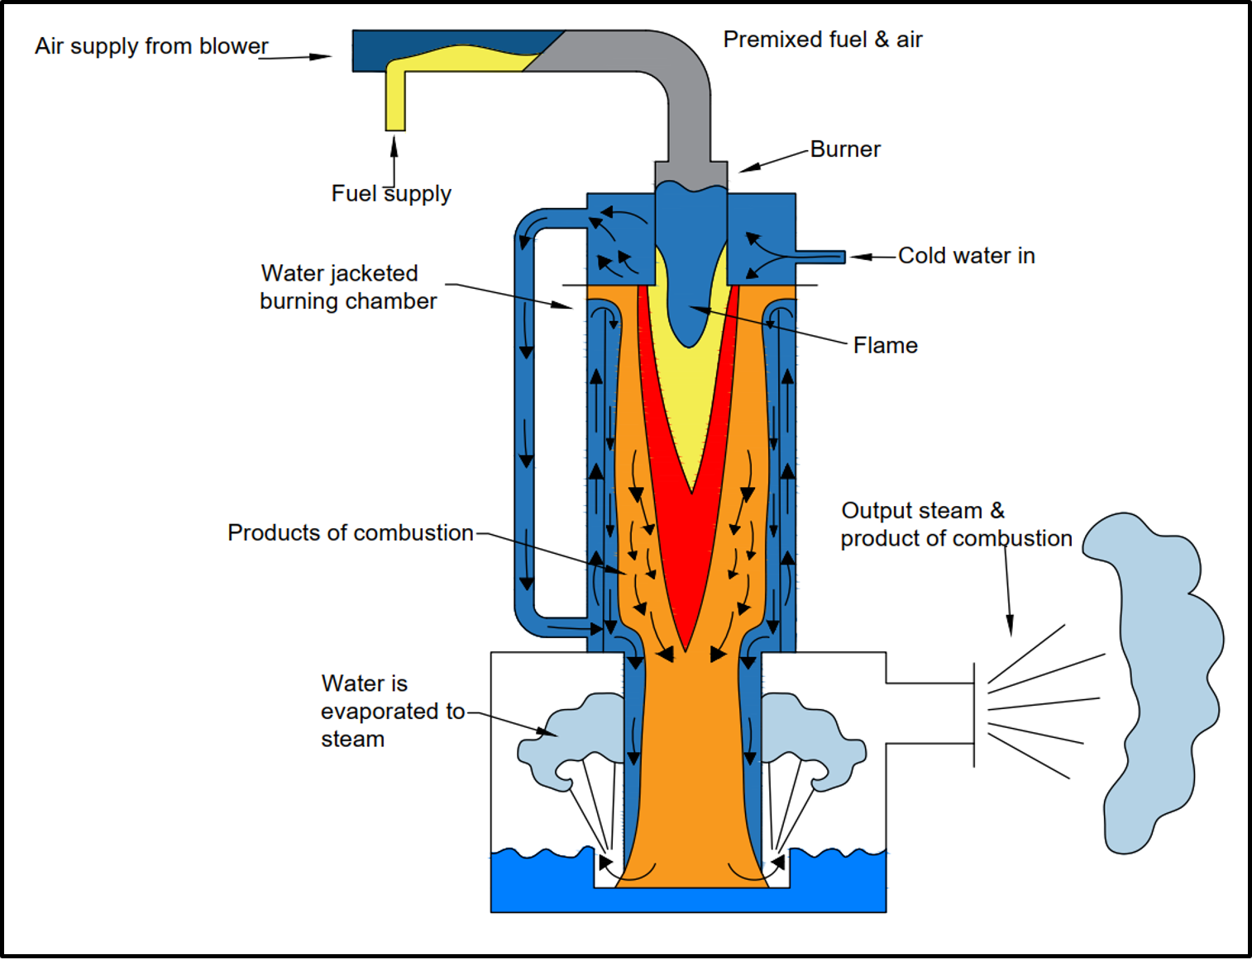
Figure 19. Schematic of AVS’ direct fired superheater.

The patented AVS superheater technology is a direct-fired superheater that injects a flame into a stream of water or steam, and superheated steam is created in one step within one vessel. All greenhouse gases are injected into the target reservoir zone making this a zero emissions technology. Temperature of the superheated steam can range from 150-650⁰C. The heater is simple and compact and has no corrosion zones. This technology is the only one that can vary the flue gas mass and gas composition from combustion up to 100% CO₂. The technology enhances both production and recovery from any reservoir type (coal, sandstone, carbonates, shale and oil shale). A major strength of the ultra-heated steam technology is that temperature is decoupled from pressure (figure 20) and thus ideally suited for shallow reservoirs with low fracture gradients such as the Forest Sandstone at Parrylands Block E. The greatly increased heavy oil mobility of superheated steam also eliminates the problems of conformance or fingering of conventional saturated steam injection and substantially increases recovery efficiency. A schematic of the superior performance of superheated steam over other methods is illustrated in figure 21.

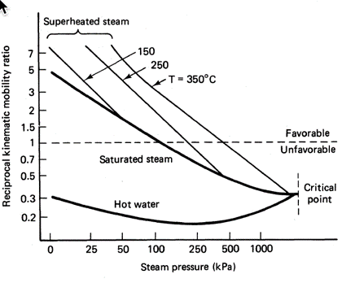
Figure 20. The relationship between Steam pressure and reciprocal kinematic mobility ratio. Superheated steam at increasingly higher temperatures increases the mobility ratio of the heavy oil without substantially increasing the steam pressure, hence temperature and pressure are decoupled with the superheated steam technology. The hotter the steam, the better the mobility ratio of the heavy oil and the greater the recovery efficiency.

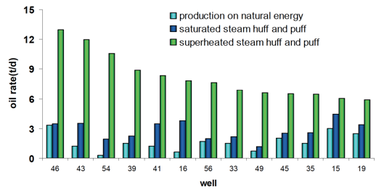
Figure 21. Schematic illustrating the advantage of superheated steam greatly increasing the per well oil production compared to other methods.

CO₂ flooding is miscible with, and dissolves into, the heavy oil permanently reducing oil viscosity at reservoir pressure. Moreover, as pressure is reduced at the production well, the CO₂ comes out of solution creating a highly effective foamy oil drive. Very high recovery efficiencies are expected and can be >80%.
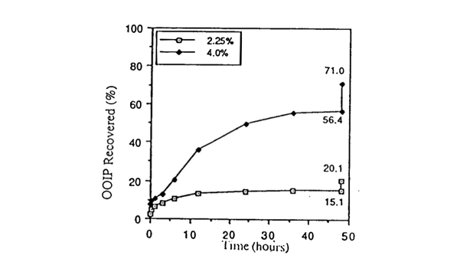
Figure 22. The effect of CO₂ concentration on oil recovery. Even small amounts of CO₂ can have a dramatic effect on oil recovery. Increasing the percentage of CO₂ from 2.25 to 4% increases recovery from 15-20% to 56.4-71%.

SMART PUMPER is a technology that allows for remote monitoring and control. Automated pump control optimizes production, extends pump life, reduces downtime and prevents damage to equipment.

Proposed Steam Injection Wells

Since the Gaffney, Cline & Associates reserves report in 2008, NHE has undertaken substantial drilling activities across Block E, particularly the 32 new vertical wells in the northern part. GCA only assigned Contingent Resources for the northern part of the field arguing that more wells were needed to provide regular producer patterns and that additional drilling would also provide more geological certainty and mitigate any fault complexity. New drilling has now been undertaken and well spacing across the core of the reservoir (net pay >50’ and the cut-off for OOIP calculations) is generally 2.5 acres or less (figure 23).

GCA did not attribute any reserve estimates to the shut-in wells in 2008 as proved not producing or proved undeveloped. There are now 110 wells in the field (100 vertical and 10 horizontal) that are drilled and completed and ready for steam injection upon raising capital for full development. With the deployment of AVS superheater technology that will enable injection of high temperature, high quality steam at injection pressures below the fracture gradient along with flue gas containing a significant percentage of CO₂ that will substantially reduce oil viscosity in the reservoir and provide a foamy drive at the wellbore, Greenflame’s proposed EOR program is expected to far outperform the analogous production in the nearby Petrotrin/Texaco steam pilot project both in terms of ultimate recovery (50% vs projected >80%) and daily oil production rates (30 bopd vs projected 75 bopd).

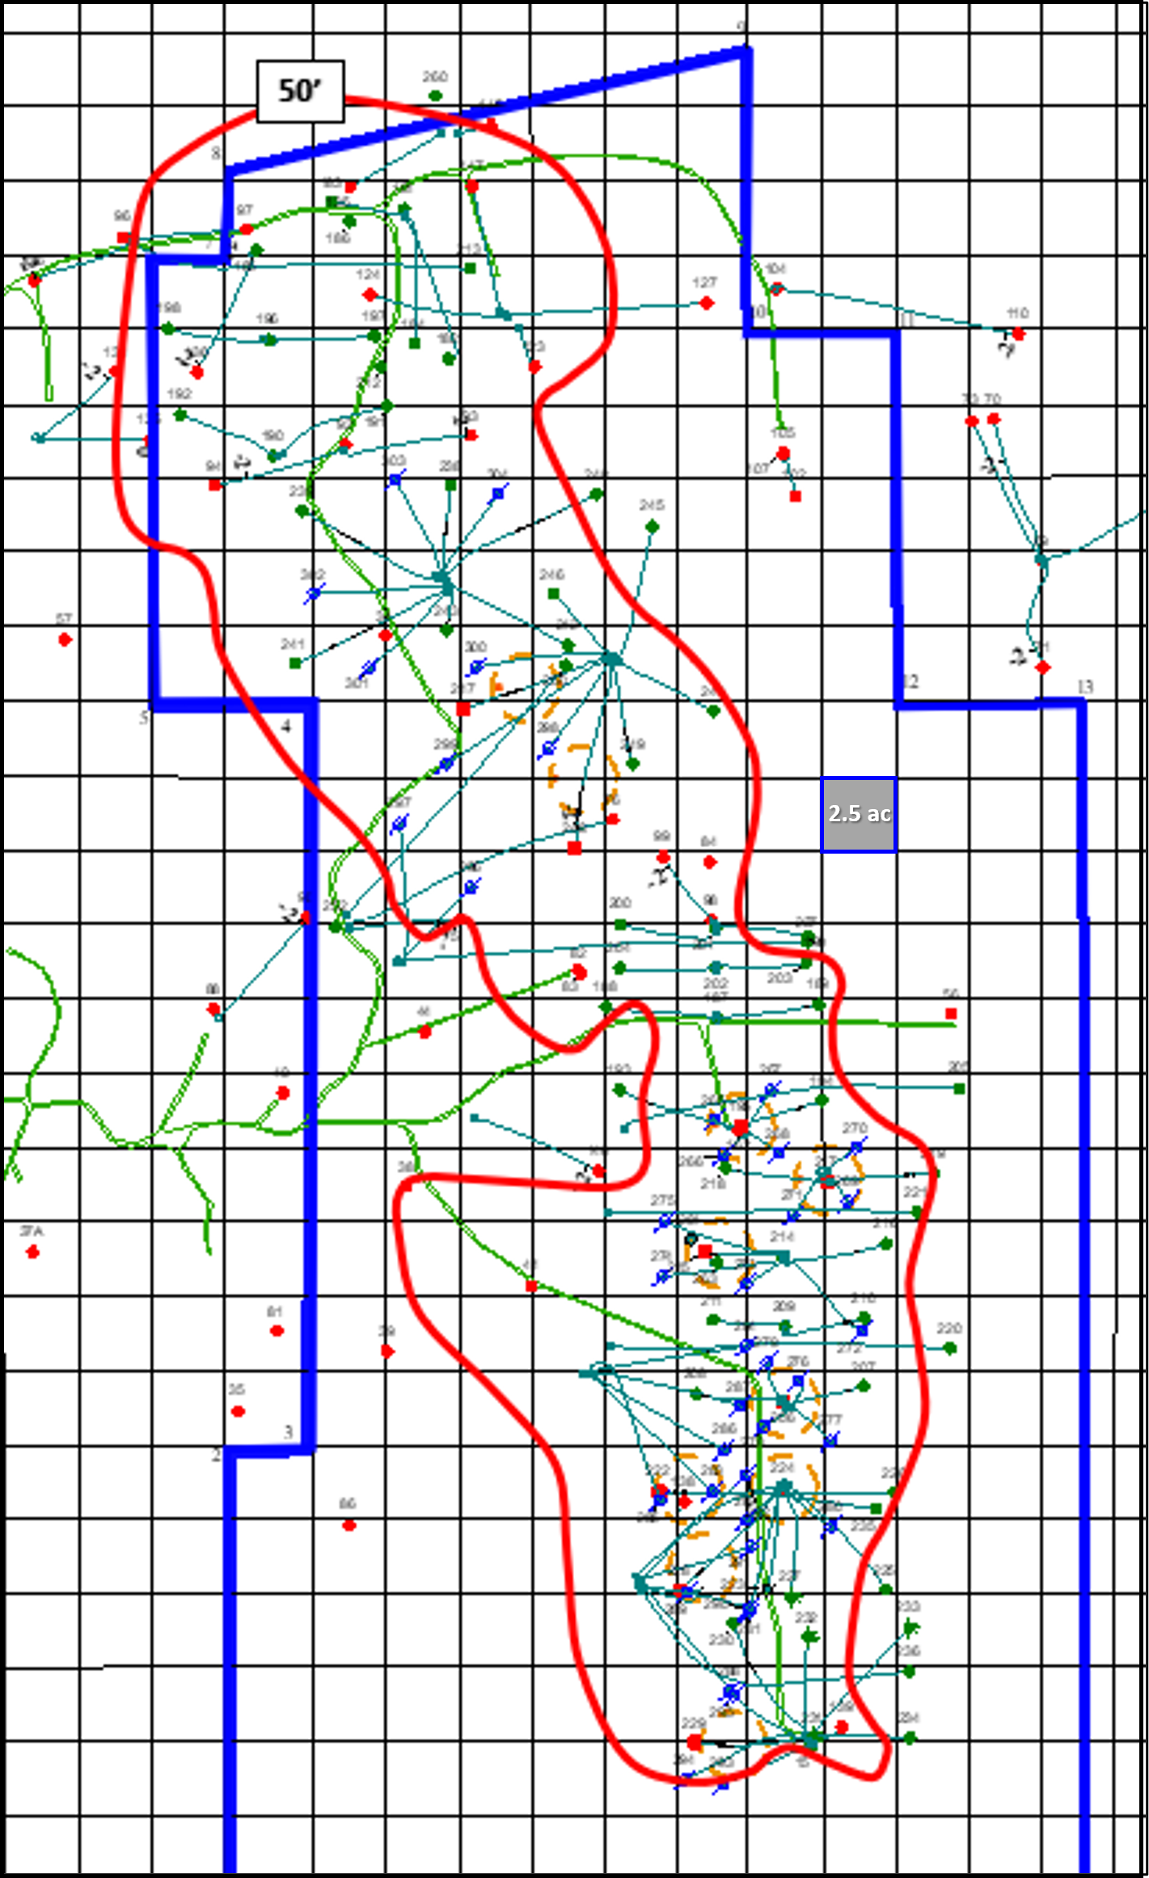
Figure 23. Well spacing in the core of net pay reservoir thickness (>50’) is generally 2.5 acres or less.

Current Activities: Completed and In Progress

Greenflame in conjunction with NHE have been undertaking the following steps for the last several years in preparation for the Enhanced Recovery (III) phase. Anticipated 5-year NET production revenue = $610,407,500; with estimated 29,379,000 P1 Reserves post EOR workover. $20MM invested to date in the 110 wells drilled including reservoir studies, development plan, field tests and infrastructure (power, roads, water, accommodations) significantly de-risking the project, prepared for EOR workover.

I: Near Wellbore Work
- Wellbore Cleanouts due to asphaltene buildup
- Install PCP pumps or sand tolerant pumps
- Smart Pumper managed wells

II: Reservoir Management
- Sand Control - Wire Wrapped Screens
- Thermal Packers
- Steam + Flue Gas

III: Enhanced Recovery
- CO₂ + Steam
- CO₂ EOR + Carbon Sequestration

Economic Modeling and Assumptions

The Trinidad Economic modeling is outlined in an excel spreadsheet that accompanies this report. Highlights of the model are illustrated here for convenience. Daily oil production is predicted to accelerate rapidly to 6,000 bopd by month 21 following deployment of superheated steam injection program (figure 24). Cash on hand is similarly predicted to accelerate rapidly with the increased daily oil production rates (figure 25). Capital and operational costs for the first 7 months of the program are shown in figure 26 below and the Financial Summary till year end 2024 is illustrated in figure 27. Additional data includes:
- Cost of new well drilling is $350,000
- Cost of outfitting a well $80,000
- Pipeline cost is estimated at 50 cents/bbl
- Owner payment $1 million Annual payment to maintain Production Sharing Agreement until 500 bopd is reached then no further payment
- Long term steam generator cost is $1.2 million
- Field improvements are 5% of gross revenue after 6 months
Taxes and Royalties are as follows:
- Government production participation 8% is govt’s cut of gross production
- Government royalty 8%
- Witholding tax 15%, generally 30% but there is a 50% reduction when using EOR
- T&T offer a tax credit of 30% of the cost of investment of up to a maximum of TT $500,000 for companies that invest in carbon capture and storage and enhanced oil recovery

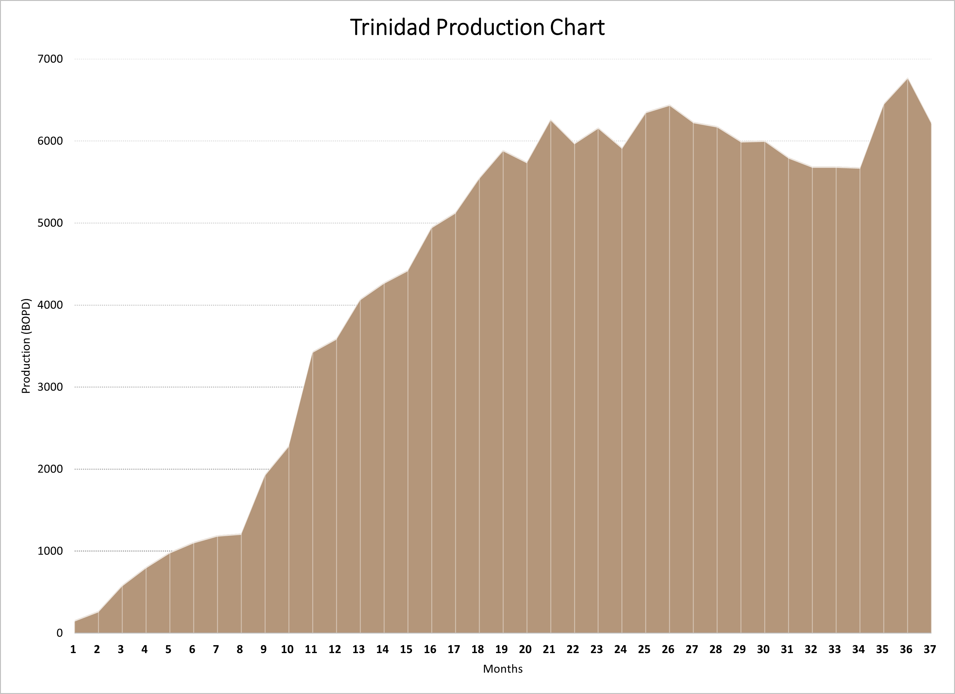
Figure 24. Upon investor capital input production at Parrylands Block E is expected to increase rapidly to more than 6,000 bopd in 20 months.

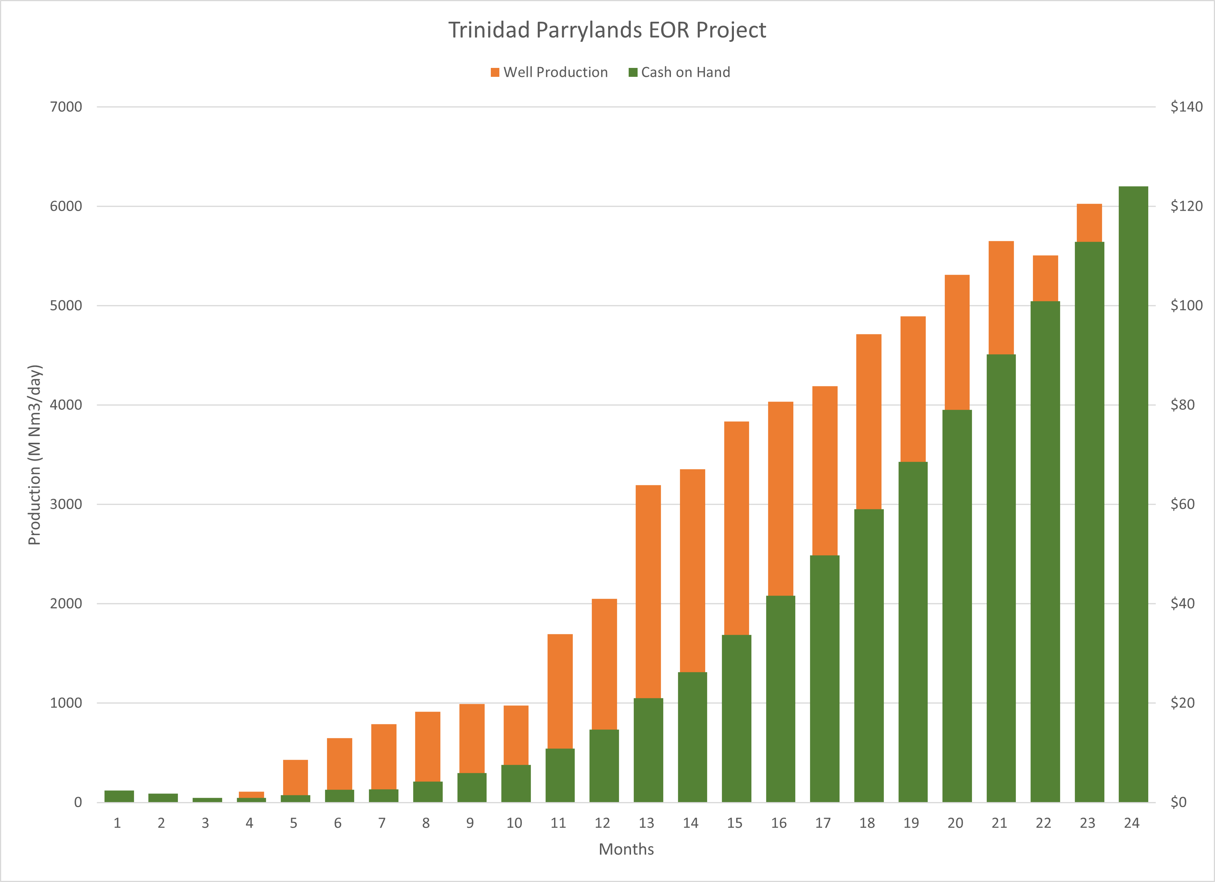
Figure 25. Cash flow will accumulate quickly with increased oil production and revenue.

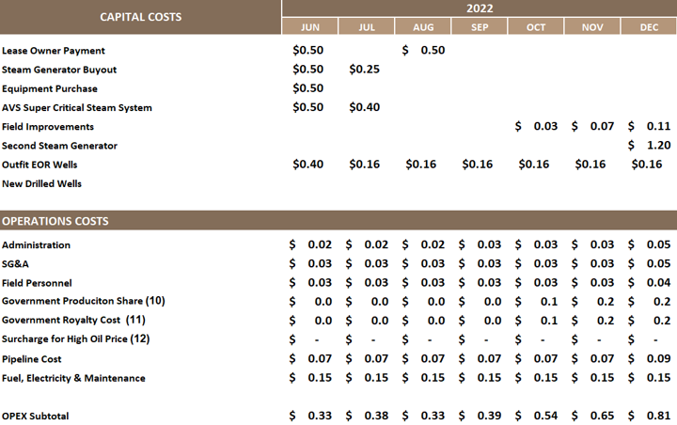
Figure 26. Capital and Operational costs for the first 7 months (in $millions)

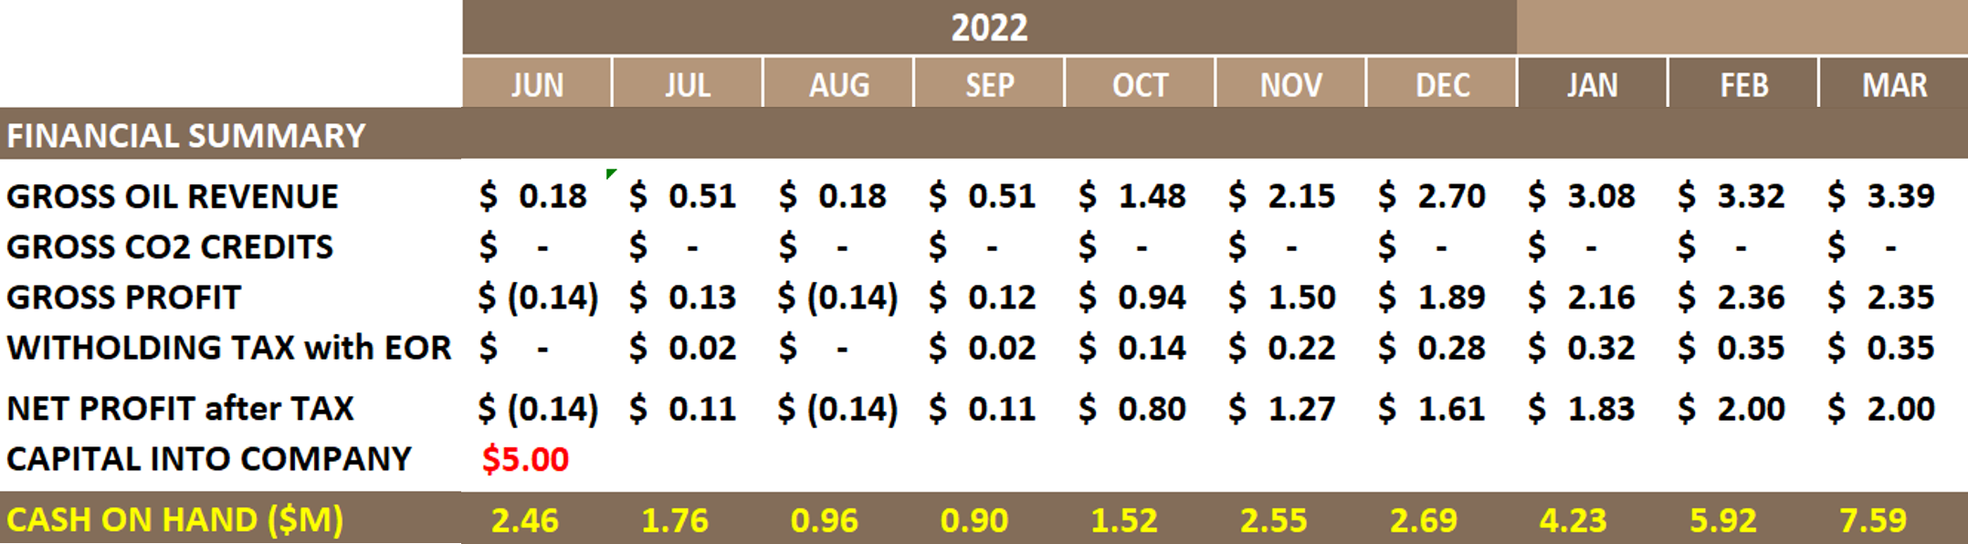
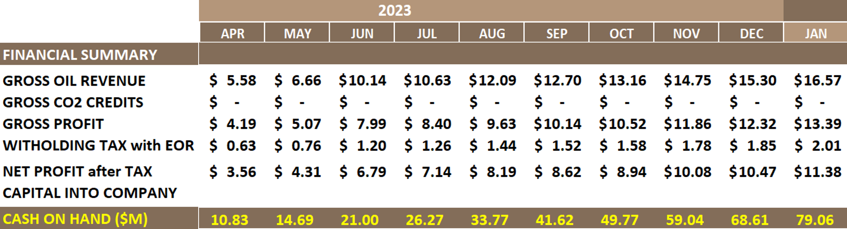
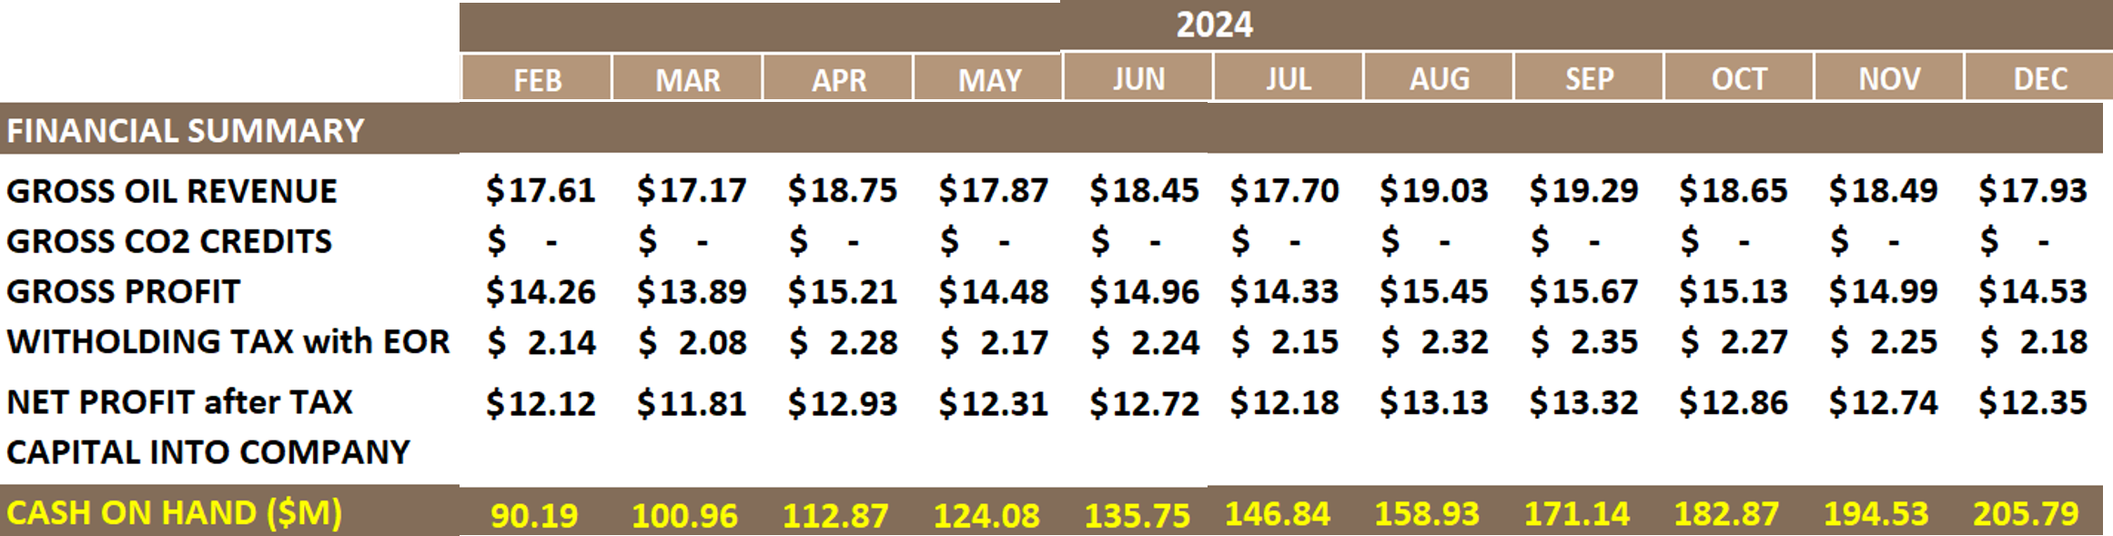
Figure 27. Financial Summary for Jun 2022-December 2024

Doing Business in Trinidad & Tobago

Trinidad and Tobago (“T&T”) consists of twin Caribbean Islands just off the NE coast of Venezuela and is an English-Speaking Democracy (former British territory). T&T attracts considerable foreign direct investment from international businesses, particularly in energy, reaching $2.4b in 2014. Energy production and downstream industrial use dominate the economy and T&T is the largest oil and gas producer in the Caribbean, producing oil & gas for over 100-years with over 3 billion barrels of oil produced to date.

T&T is the 3rd richest country by GDP per capita ($32.35B in 2015) in the Americas after the U.S.A and Canada, 40% of GDP coming from Oil & Gas. Judicial system upholds the sanctity of contracts and generally provides a level playing field for foreign investors involved in court matters (US Embassy) via The Foreign Investment Act of 1990. Robust economic and political relationship with U.S achieving “Most Favored Nation” Status with U.S. The United States is the country’s largest trading partner, accounting for 33% of its total imports and taking 44% of its exports. Paid in U.S. Dollars / Free Flow of Capital through bank wire.

Proven oil reserves estimated by EIA in 2013 at 728 million barrels / 3P at 25.24 trillion cubic feet of natural gas. In 2013, T&T was the world’s sixth-largest liquefied natural gas (LNG) exporter and is home to one of the largest natural gas liquefaction facilities in the Western Hemisphere, the Phoenix Park Gas Processors Limited (“PPGPL”) is capable of processing up to 1.95 Bscf of natural gas per day. With 11 ammonia plants and seven methanol plants, Trinidad and Tobago is the world’s largest exporter of ammonia and the second largest exporter of methanol globally. Major Players include Atlantic LNG, British Gas, BP, Texaco, BHP, Chevron, EOG, Niko Resources, Range Resources and Trinmar.

Conclusions

Since GCA certified Proved Reserves of 1,379 Mstb (1P), Proved + Probable of 9,908 Mstb (2P), Proved + Probable + Possible 13,675 Mstb (3P) and 17,933 Mstb of Contingent Resources from an OOIP estimate of 81 MMBO in 2008, New Horizon Energy and Greenflame Energy Inc have invested on the order of $20MM in new well drilling, well workovers, pump installations and improved reservoir management activities in Block E of the Parrylands field. Greenflame has introduced the advanced EOR technologies of superheated steam & flue gas (up to 100% CO₂) injection and CO₂ sequestration that are now available for deployment in the 110 existing wells in the field and is seeking an updated and upgraded resource and reserves certification from Netherland Sewell and Associates (NSAI) to inform potential investor capital. GCA classified Contingent Resources only in the northern half of Block E citing the lack of a development plan and geological uncertainty because of insufficient well density. NHE has since drilled 32 new wells in the north such that the fieldwide well spacing is now 2.5-acres or less.

Heavy oil residing in the high-quality reservoirs of the Forest Sandstone proved commercially producible by thermal stimulation methods from the highly successful 30-acre steam pilot adjacent to the western boundary of Block E. Undertaken by Petrotrin/Texaco from 1981-2003, the thermal pilot recovered ~50% of the 6.1 MMBO of OOIP at peak producing rates of 750 bopd from 16 wells. Greenflame’s advanced thermal stimulation technologies are predicted to substantially outperform Petrotrin/Texaco’s steam pilot with recovery efficiency modeling projections above 80%. The wells are ready for implementation of the advanced EOR program upon raising investor capital and the economic evaluation promises a low cost, high netback and, with the added potential for substantial CO₂ sequestration, potentially carbon neutral oil production.

References

Gaffney, Cline and Associates, 2008, Resource and Reserves Certification of the Parrylands field, Block E, Trinidad.

Rambarran, H., 1987, Significance of gravity segregation in heavy oil distribution, Forest ‘A’ reservoir, Parrylands Field, Trinidad, West Indies: Section III. Geological Environments and Migration. American Association of Petroleum Geologists, Special Publication, Studies in Geology # 25, p.281-291.

Salvador, A., and Stainforth, R.M., 1968, Clues in Venezuela to the geology of Trinidad, and vice-versa: Transactions of the IV Caribbean Geological Conference, Trinidad, p.31-40.

Appendix 1: Audit Wells

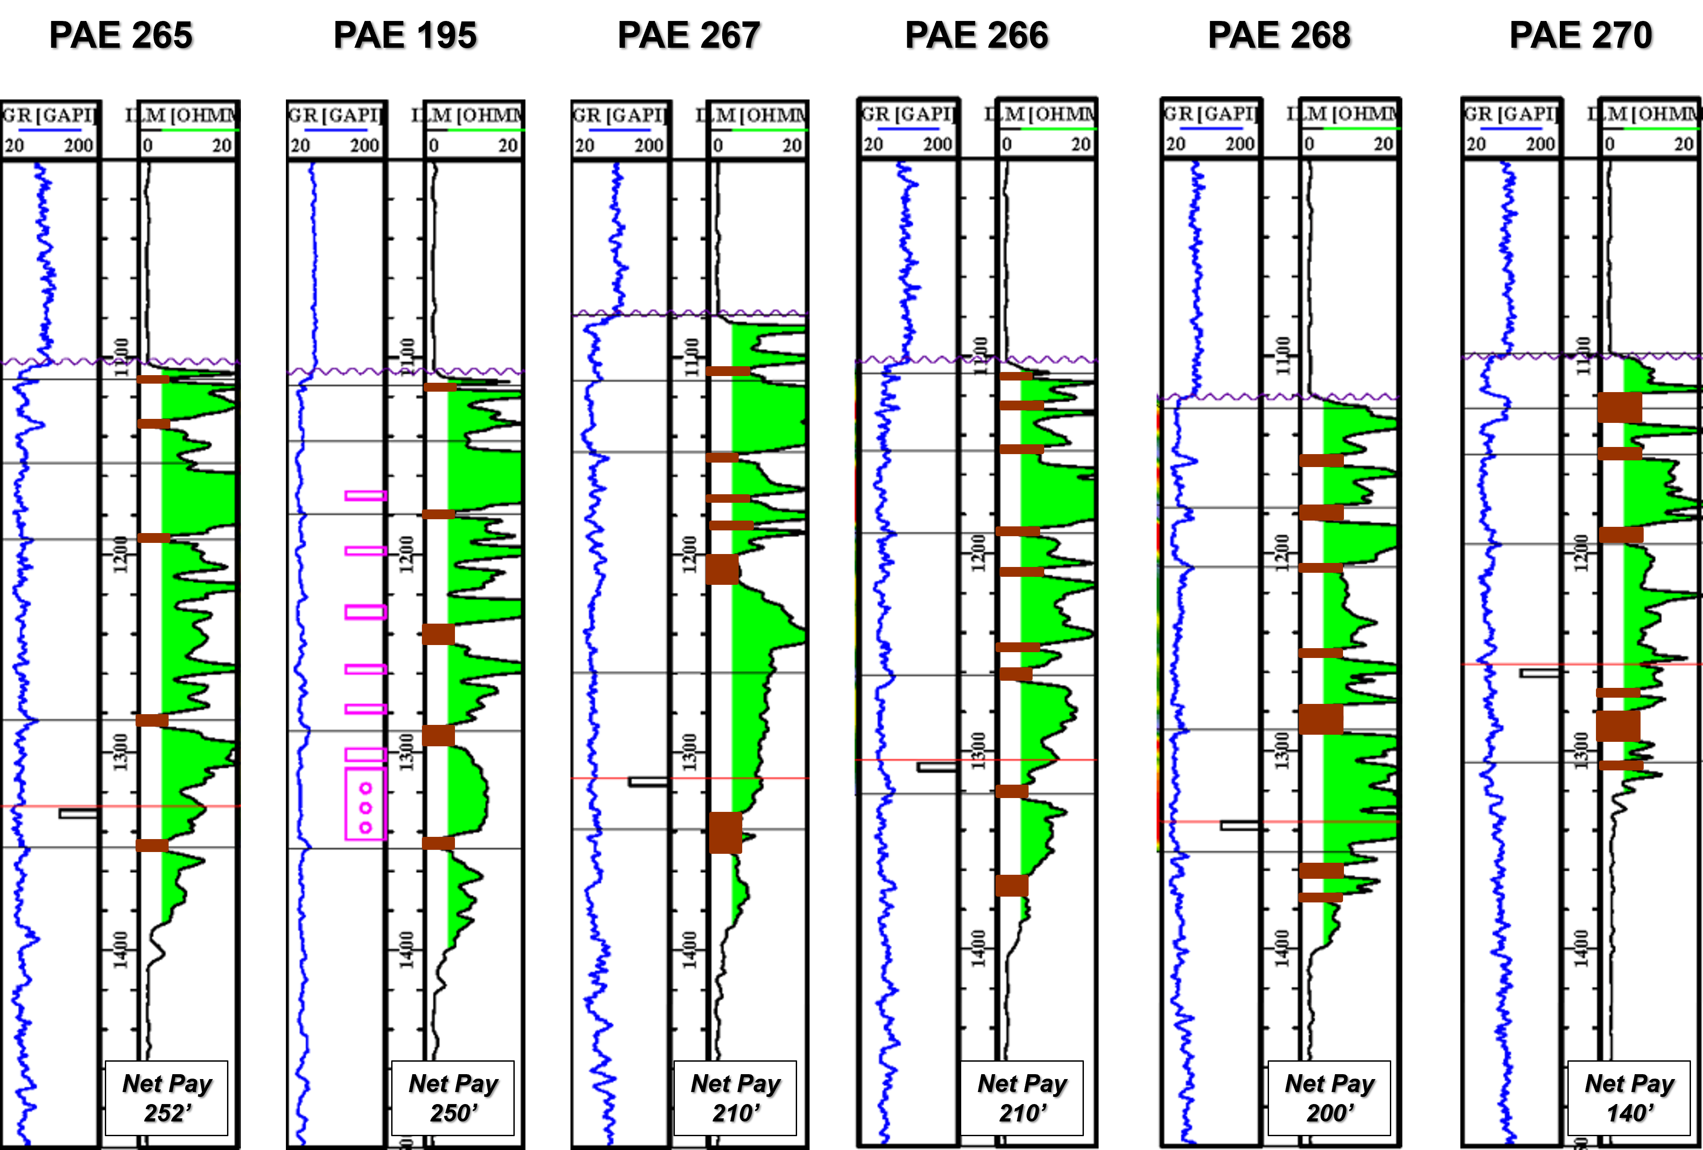

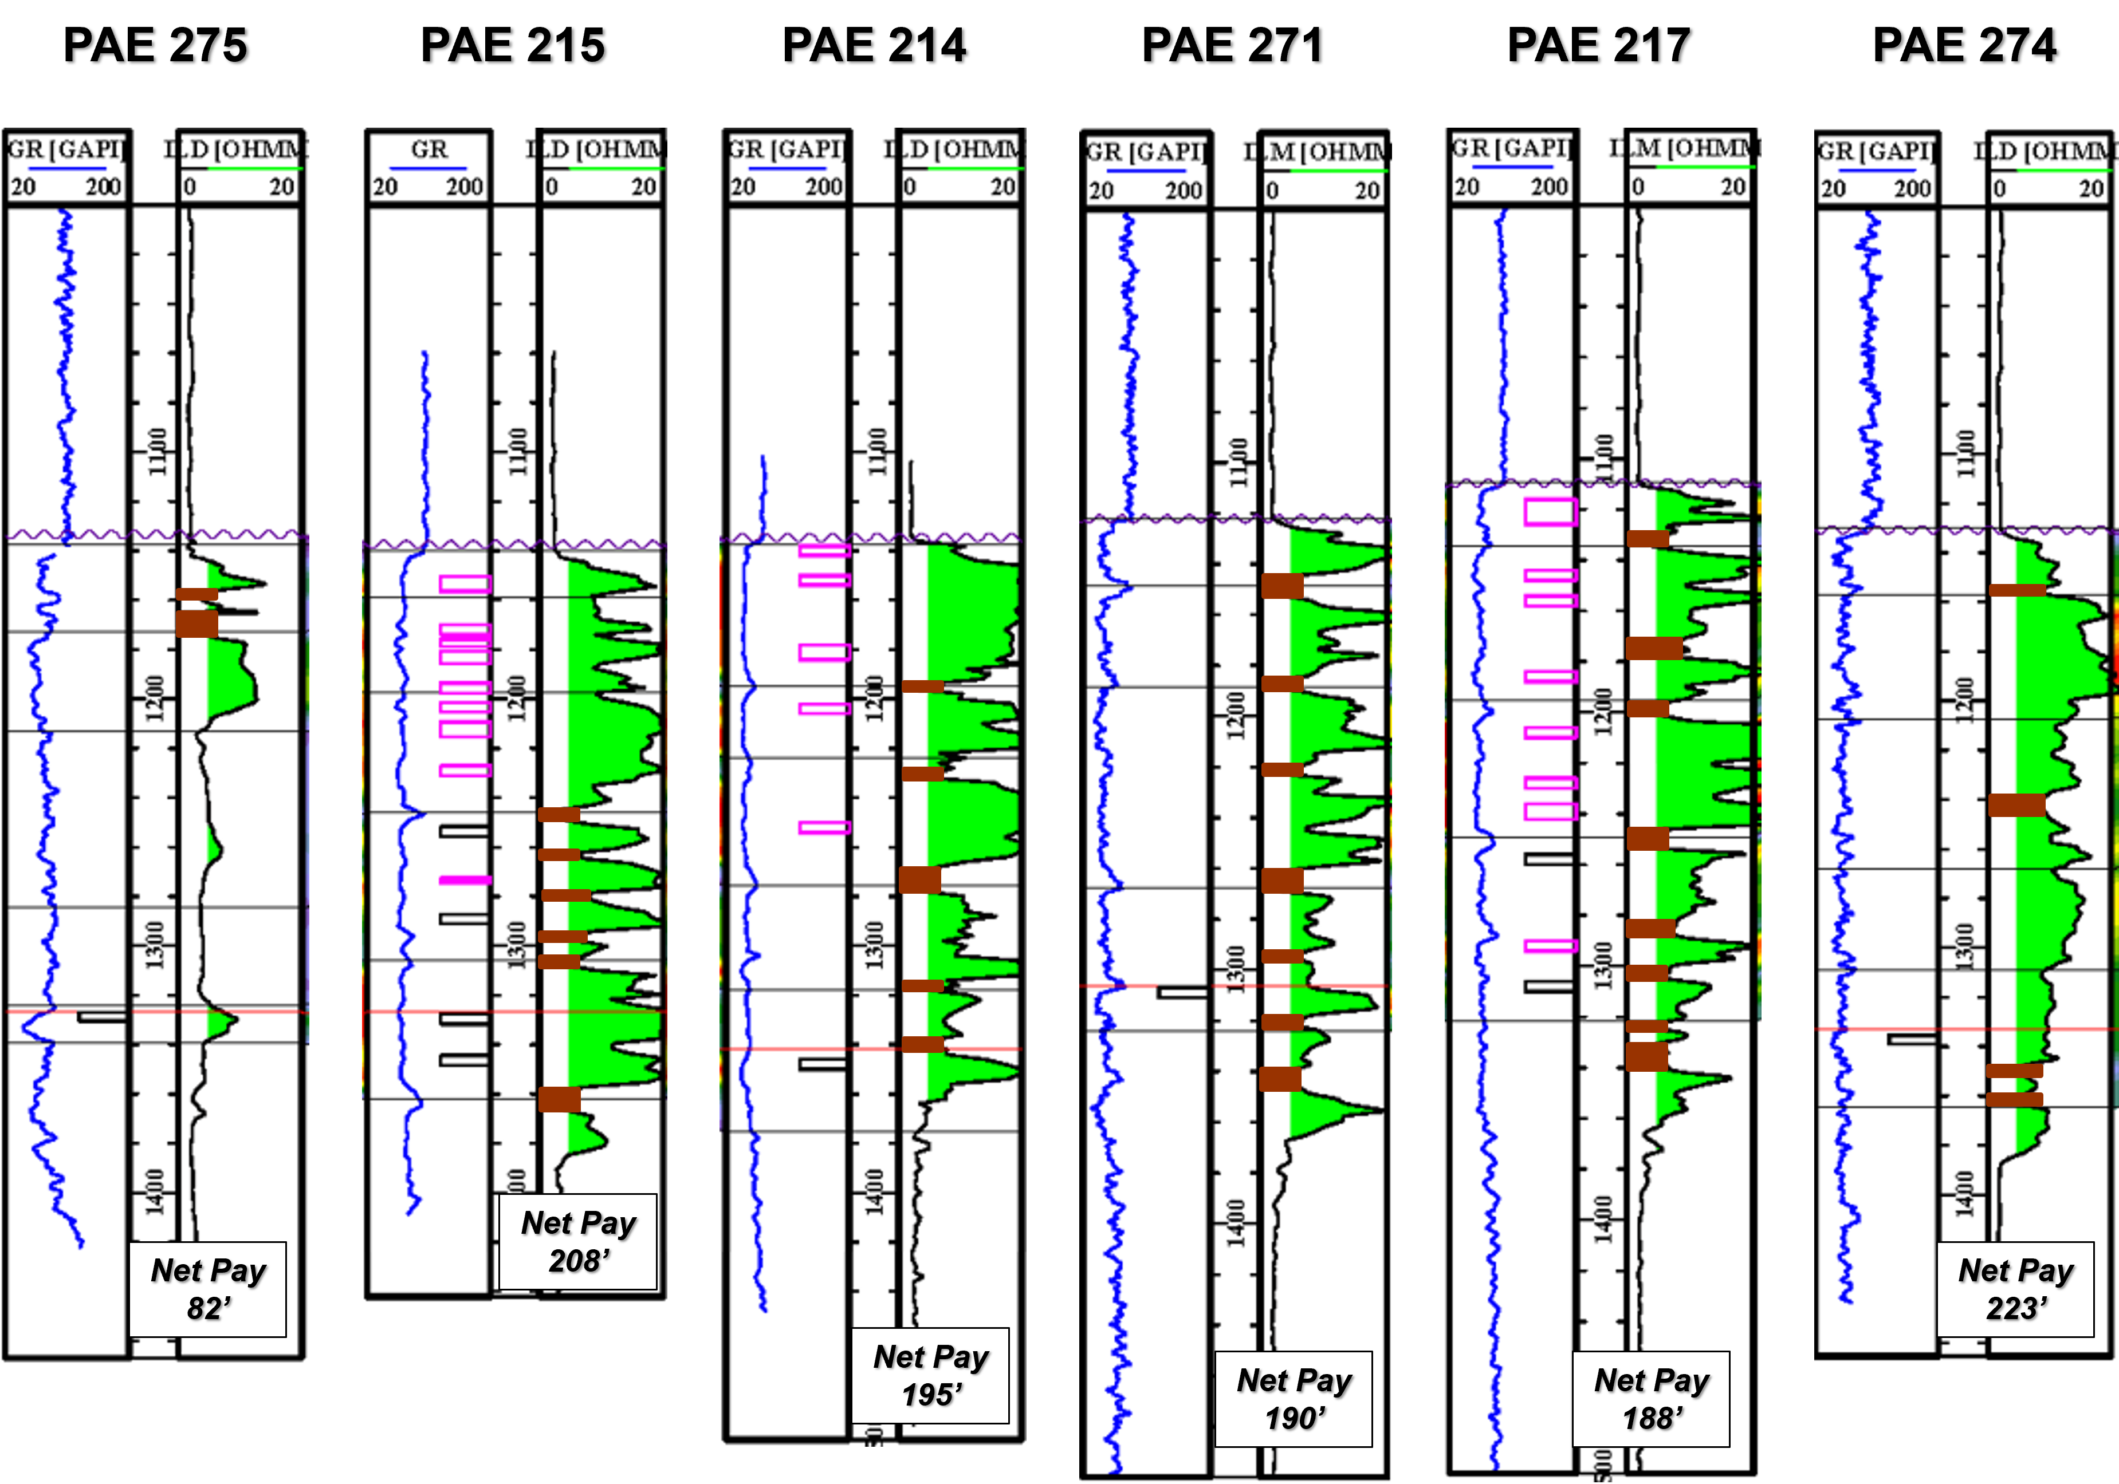
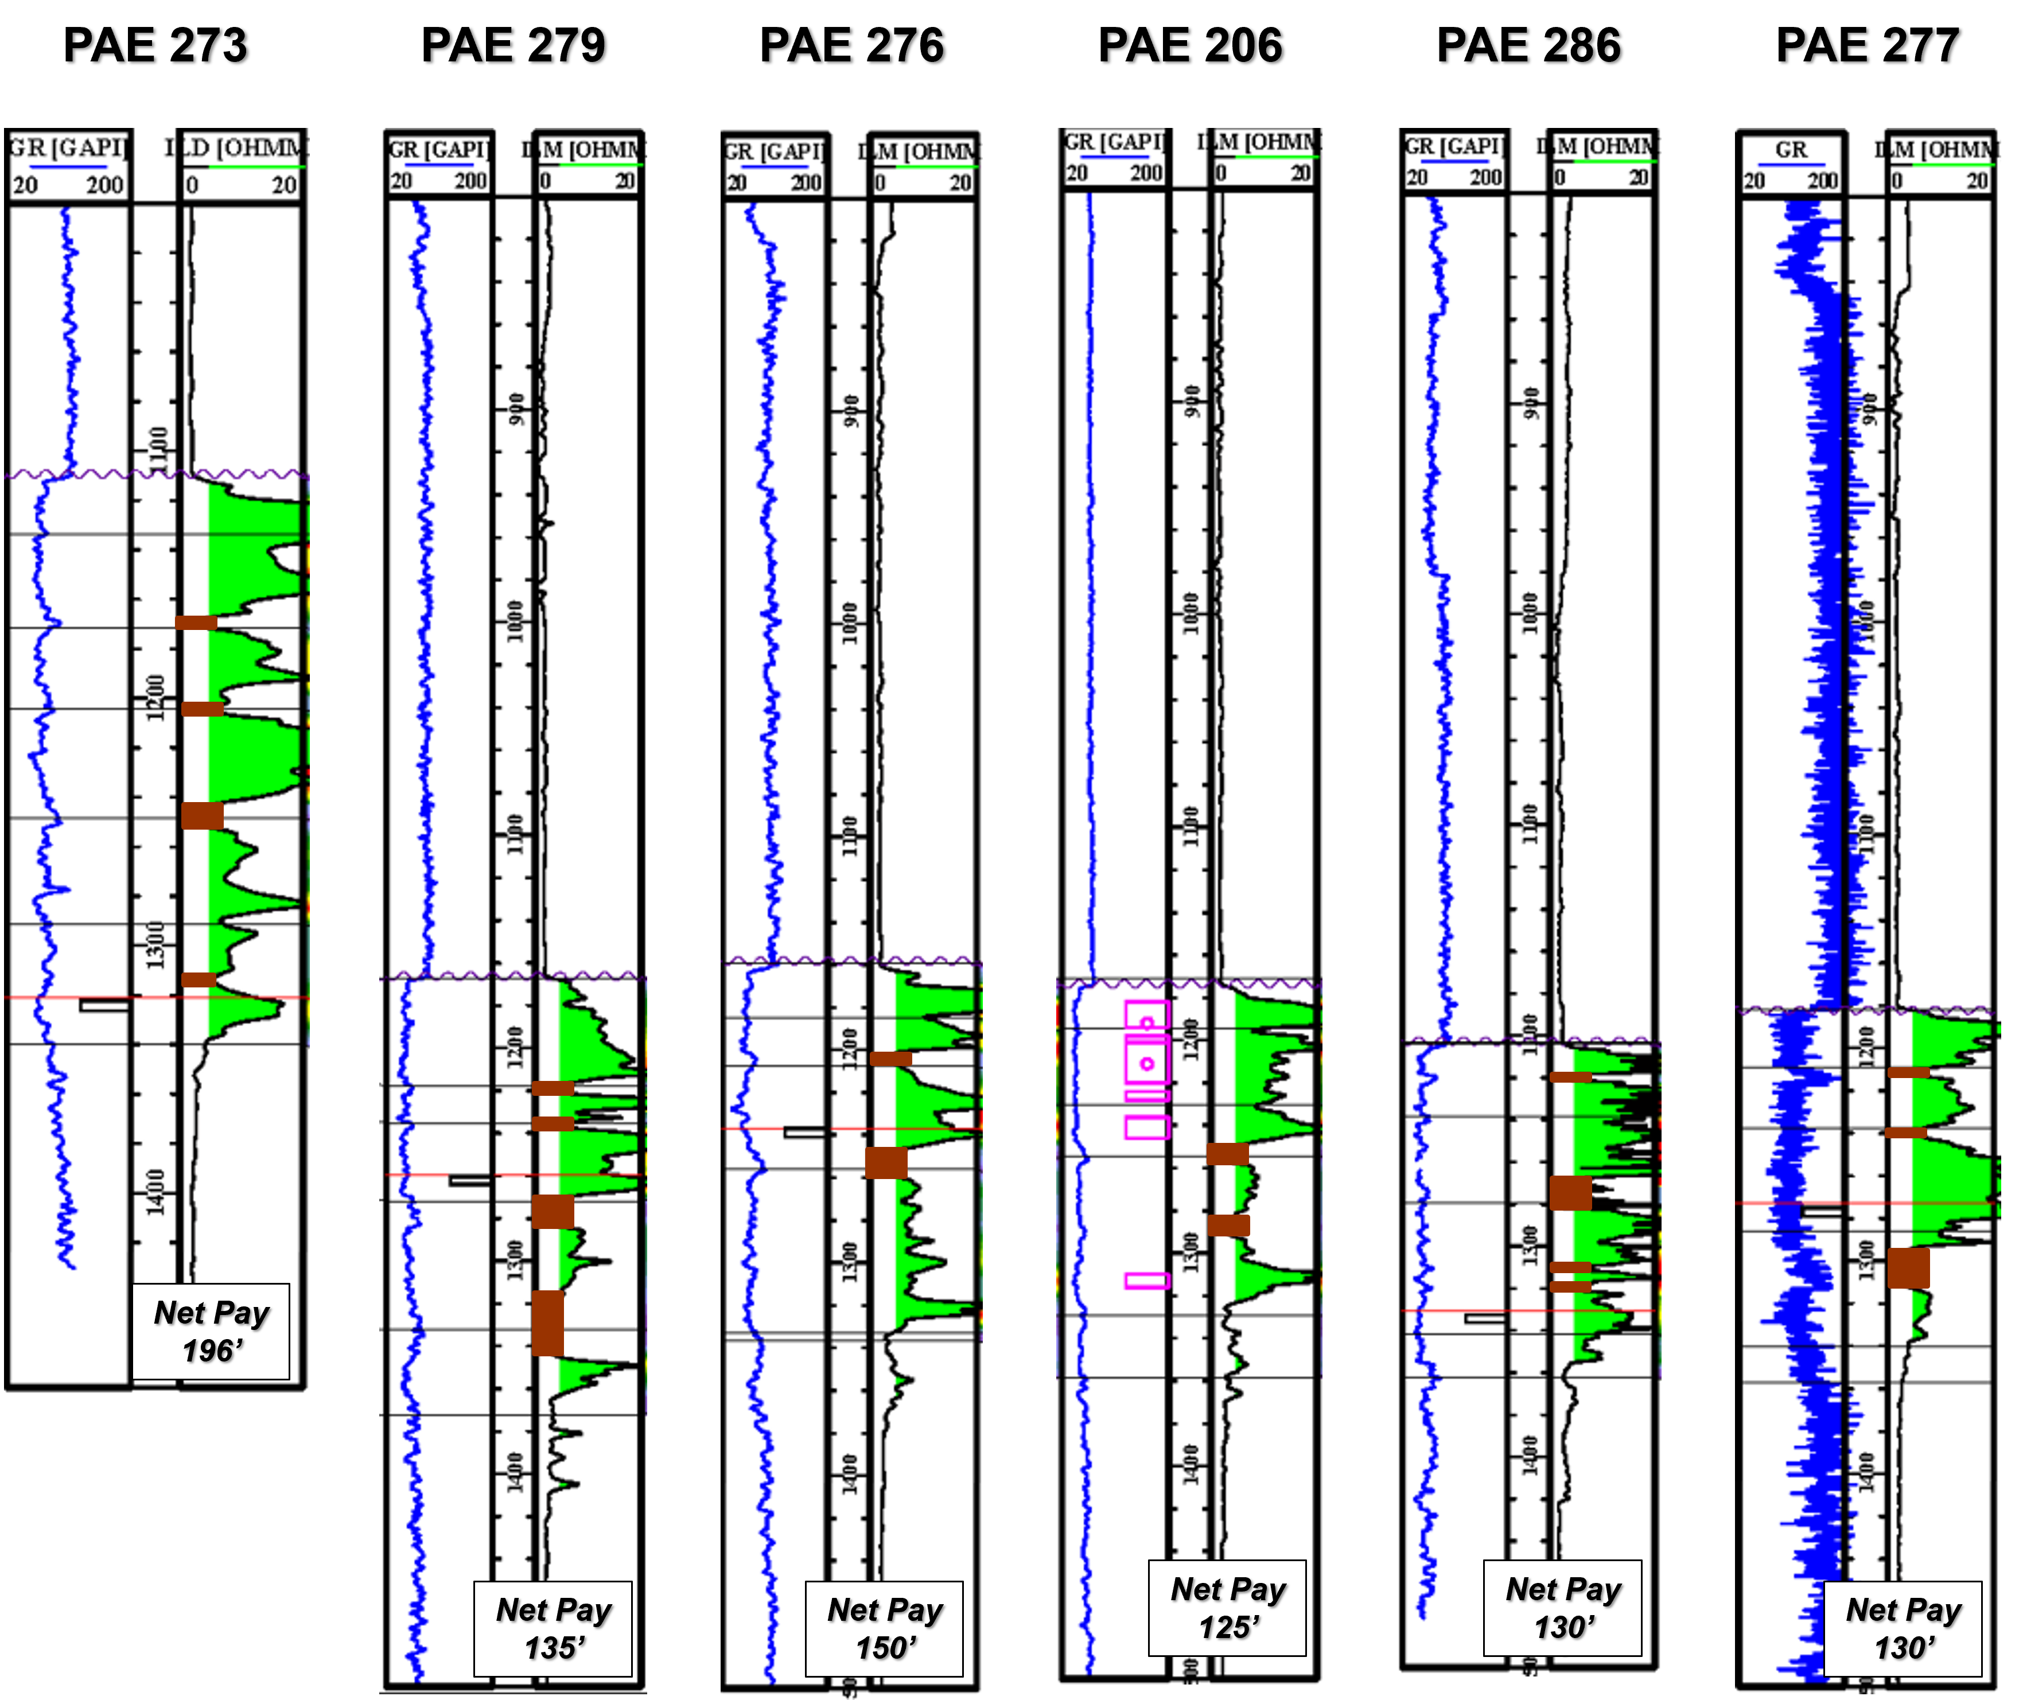

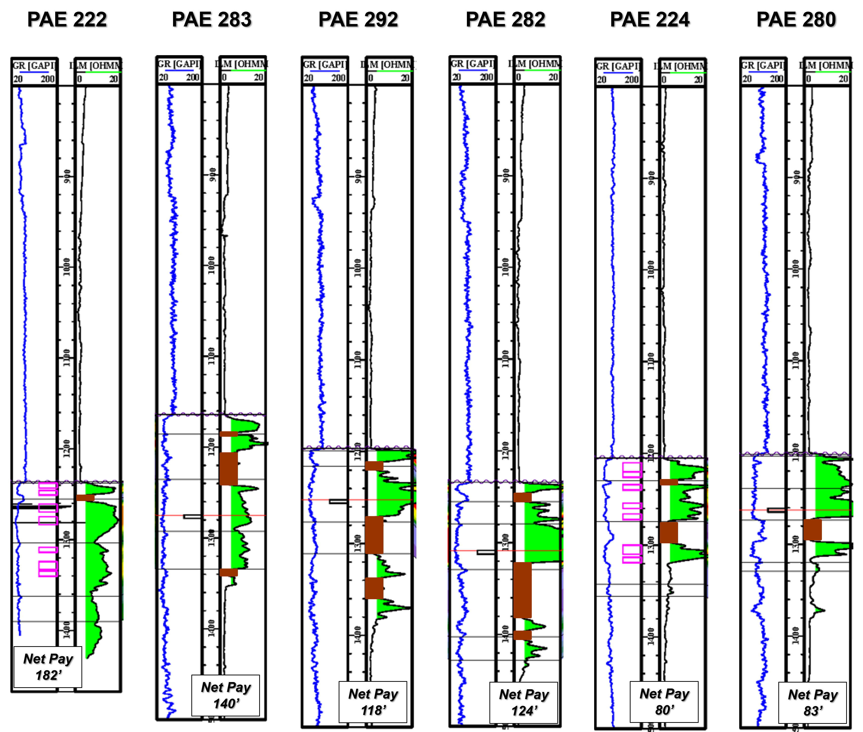

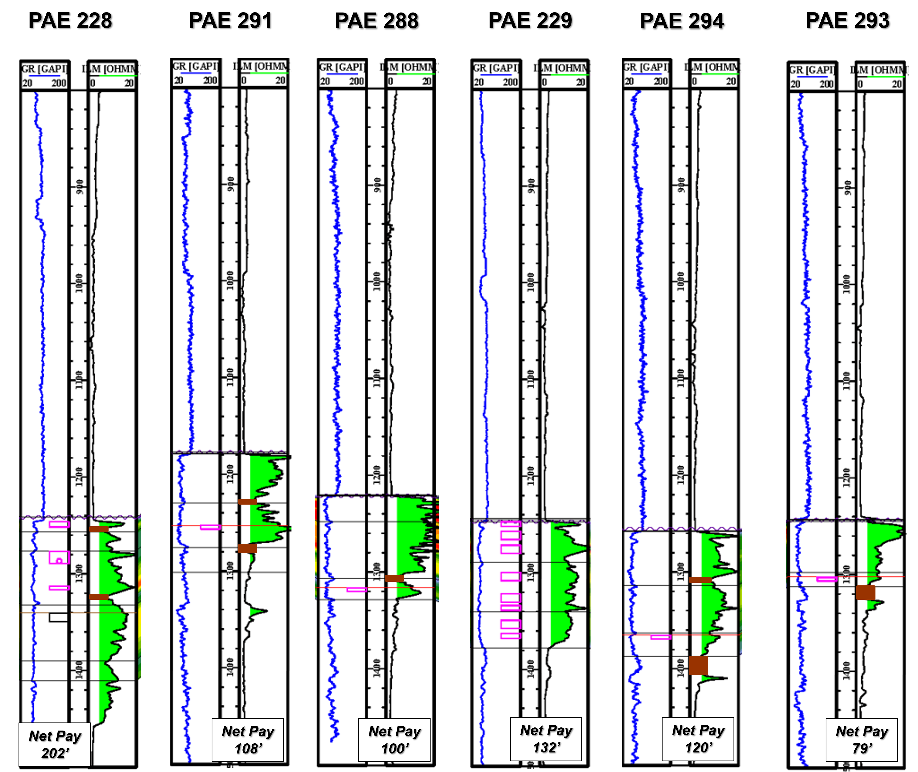

Appendix 2: Calculation of OOIP based on Audited Net Pay Map

Block # | Area | Thickness | Porosity | 1-Sw | Constant | FVF | OOIP
 | (acres) | (ft) | (decimal) | (decimal) | 7758 |  | (barrels)
1 | 1.35 | 100 | 0.34 | 0.75 | 7758 | 1 | 267,069
2 | 2.5 | 100 | 0.34 | 0.75 | 7758 | 1 | 494,573
3 | 2.5 | 100 | 0.34 | 0.75 | 7758 | 1 | 494,573
4 | 2.5 | 90 | 0.34 | 0.75 | 7758 | 1 | 445,115
5 | 1.875 | 75 | 0.34 | 0.75 | 7758 | 1 | 278,197
6 | 0.6 | 60 | 0.34 | 0.75 | 7758 | 1 | 71,218
7 | 0.75 | 80 | 0.34 | 0.75 | 7758 | 1 | 118,697
8 | 2.5 | 165 | 0.34 | 0.75 | 7758 | 1 | 816,045
9 | 2.5 | 185 | 0.34 | 0.75 | 7758 | 1 | 914,959
10 | 2.5 | 190 | 0.34 | 0.75 | 7758 | 1 | 939,688
11 | 2.5 | 175 | 0.34 | 0.75 | 7758 | 1 | 865,502
12 | 2.5 | 85 | 0.34 | 0.75 | 7758 | 1 | 420,387
13 | 2.19 | 70 | 0.34 | 0.75 | 7758 | 1 | 303,272
14 | 1.25 | 80 | 0.34 | 0.75 | 7758 | 1 | 197,829
15 | 2.5 | 165 | 0.34 | 0.75 | 7758 | 1 | 816,045
16 | 2.5 | 225 | 0.34 | 0.75 | 7758 | 1 | 1,112,788
17 | 2.5 | 240 | 0.34 | 0.75 | 7758 | 1 | 1,186,974
18 | 2.5 | 175 | 0.34 | 0.75 | 7758 | 1 | 865,502
19 | 2.5 | 90 | 0.34 | 0.75 | 7758 | 1 | 445,115
20 | 2.5 | 65 | 0.34 | 0.75 | 7758 | 1 | 321,472
21 | 2.5 | 75 | 0.34 | 0.75 | 7758 | 1 | 370,929
22 | 2.5 | 140 | 0.34 | 0.75 | 7758 | 1 | 692,402
23 | 2.5 | 160 | 0.34 | 0.75 | 7758 | 1 | 791,316
24 | 2.5 | 140 | 0.34 | 0.75 | 7758 | 1 | 692,402
25 | 2.5 | 135 | 0.34 | 0.75 | 7758 | 1 | 667,673
26 | 2.5 | 90 | 0.34 | 0.75 | 7758 | 1 | 445,115
27 | 1.3 | 65 | 0.34 | 0.75 | 7758 | 1 | 167,166
28 | 1.25 | 110 | 0.34 | 0.75 | 7758 | 1 | 272,015
29 | 2.5 | 150 | 0.34 | 0.75 | 7758 | 1 | 741,859
30 | 2.5 | 100 | 0.34 | 0.75 | 7758 | 1 | 494,573
31 | 2.5 | 165 | 0.34 | 0.75 | 7758 | 1 | 816,045
32 | 2.5 | 175 | 0.34 | 0.75 | 7758 | 1 | 865,502
33 | 2.5 | 100 | 0.34 | 0.75 | 7758 | 1 | 494,573
34 | 0.625 | 60 | 0.34 | 0.75 | 7758 | 1 | 74,186
35 | 0.625 | 80 | 0.34 | 0.75 | 7758 | 1 | 98,915
36 | 2.5 | 75 | 0.34 | 0.75 | 7758 | 1 | 370,929
37 | 2.5 | 80 | 0.34 | 0.75 | 7758 | 1 | 395,658
38 | 2.5 | 150 | 0.34 | 0.75 | 7758 | 1 | 741,859
39 | 2.5 | 180 | 0.34 | 0.75 | 7758 | 1 | 890,231
40 | 2.5 | 165 | 0.34 | 0.75 | 7758 | 1 | 816,045
41 | 1.875 | 140 | 0.34 | 0.75 | 7758 | 1 | 519,301
42 | 1.2 | 55 | 0.34 | 0.75 | 7758 | 1 | 130,567
43 | 2.5 | 85 | 0.34 | 0.75 | 7758 | 1 | 420,387
44 | 2.5 | 150 | 0.34 | 0.75 | 7758 | 1 | 741,859
45 | 2.5 | 190 | 0.34 | 0.75 | 7758 | 1 | 939,688
46 | 2.5 | 150 | 0.34 | 0.75 | 7758 | 1 | 741,859
47 | 2.5 | 85 | 0.34 | 0.75 | 7758 | 1 | 420,387
48 | 1.25 | 60 | 0.34 | 0.75 | 7758 | 1 | 148,372
49 | 2.5 | 75 | 0.34 | 0.75 | 7758 | 1 | 370,929
50 | 2.5 | 130 | 0.34 | 0.75 | 7758 | 1 | 642,944
51 | 2.5 | 195 | 0.34 | 0.75 | 7758 | 1 | 964,416
52 | 2.5 | 150 | 0.34 | 0.75 | 7758 | 1 | 741,859
53 | 2.5 | 90 | 0.34 | 0.75 | 7758 | 1 | 445,115
54 | 2.5 | 75 | 0.34 | 0.75 | 7758 | 1 | 370,929
55 | 1.25 | 60 | 0.34 | 0.75 | 7758 | 1 | 148,372
56 | 1.2 | 60 | 0.34 | 0.75 | 7758 | 1 | 142,437
57 | 2.5 | 80 | 0.34 | 0.75 | 7758 | 1 | 395,658
58 | 2.5 | 125 | 0.34 | 0.75 | 7758 | 1 | 618,216
59 | 2.5 | 175 | 0.34 | 0.75 | 7758 | 1 | 865,502
60 | 2.5 | 110 | 0.34 | 0.75 | 7758 | 1 | 544,030
61 | 2.5 | 80 | 0.34 | 0.75 | 7758 | 1 | 395,658
62 | 2.5 | 65 | 0.34 | 0.75 | 7758 | 1 | 321,472
63 | 1.25 | 65 | 0.34 | 0.75 | 7758 | 1 | 160,736
64 | 2.5 | 100 | 0.34 | 0.75 | 7758 | 1 | 494,573
65 | 2.5 | 175 | 0.34 | 0.75 | 7758 | 1 | 865,502
66 | 2.5 | 135 | 0.34 | 0.75 | 7758 | 1 | 667,673
67 | 2.5 | 80 | 0.34 | 0.75 | 7758 | 1 | 395,658
68 | 2.5 | 65 | 0.34 | 0.75 | 7758 | 1 | 321,472
69 | 2.5 | 75 | 0.34 | 0.75 | 7758 | 1 | 370,929
70 | 2.5 | 100 | 0.34 | 0.75 | 7758 | 1 | 494,573
71 | 2.5 | 135 | 0.34 | 0.75 | 7758 | 1 | 667,673
72 | 2.5 | 85 | 0.34 | 0.75 | 7758 | 1 | 420,387
73 | 2.25 | 65 | 0.34 | 0.75 | 7758 | 1 | 289,325
74 | 1.75 | 75 | 0.34 | 0.75 | 7758 | 1 | 259,651
75 | 2.5 | 100 | 0.34 | 0.75 | 7758 | 1 | 494,573
76 | 2.5 | 75 | 0.34 | 0.75 | 7758 | 1 | 370,929
77 | 2.5 | 95 | 0.34 | 0.75 | 7758 | 1 | 469,844
78 | 1.75 | 110 | 0.34 | 0.75 | 7758 | 1 | 380,821
79 | 1.875 | 65 | 0.34 | 0.75 | 7758 | 1 | 241,104
80 | 1.2 | 90 | 0.34 | 0.75 | 7758 | 1 | 213,655
81 | 2.5 | 150 | 0.34 | 0.75 | 7758 | 1 | 741,859
82 | 2.5 | 125 | 0.34 | 0.75 | 7758 | 1 | 618,216
83 | 1.25 | 90 | 0.34 | 0.75 | 7758 | 1 | 222,558
84 | 2.5 | 225 | 0.34 | 0.75 | 7758 | 1 | 1,112,788
85 | 2.5 | 130 | 0.34 | 0.75 | 7758 | 1 | 642,944
86 | 1.875 | 95 | 0.34 | 0.75 | 7758 | 1 | 352,383
87 | 1.2 | 60 | 0.34 | 0.75 | 7758 | 1 | 142,437
88 | 1.3 | 60 | 0.34 | 0.75 | 7758 | 1 | 154,307
89 | 1.25 | 65 | 0.34 | 0.75 | 7758 | 1 | 160,736
90 | 1.875 | 75 | 0.34 | 0.75 | 7758 | 1 | 278,197
91 | 2.5 | 150 | 0.34 | 0.75 | 7758 | 1 | 741,859
92 | 2.5 | 210 | 0.34 | 0.75 | 7758 | 1 | 1,038,602
93 | 2.5 | 135 | 0.34 | 0.75 | 7758 | 1 | 667,673
94 | 1.1 | 75 | 0.34 | 0.75 | 7758 | 1 | 163,209
95 | 1.875 | 65 | 0.34 | 0.75 | 7758 | 1 | 241,104
96 | 2.5 | 80 | 0.34 | 0.75 | 7758 | 1 | 395,658
97 | 2.5 | 110 | 0.34 | 0.75 | 7758 | 1 | 544,030
98 | 2.5 | 145 | 0.34 | 0.75 | 7758 | 1 | 717,130
99 | 2.5 | 210 | 0.34 | 0.75 | 7758 | 1 | 1,038,602
100 | 2.5 | 210 | 0.34 | 0.75 | 7758 | 1 | 1,038,602
101 | 2.5 | 125 | 0.34 | 0.75 | 7758 | 1 | 618,216
102 | 0.5 | 55 | 0.34 | 0.75 | 7758 | 1 | 54,403
103 | 1.2 | 55 | 0.34 | 0.75 | 7758 | 1 | 130,567
104 | 2.5 | 75 | 0.34 | 0.75 | 7758 | 1 | 370,929
105 | 2.5 | 115 | 0.34 | 0.75 | 7758 | 1 | 568,758
106 | 2.5 | 145 | 0.34 | 0.75 | 7758 | 1 | 717,130
107 | 2.5 | 185 | 0.34 | 0.75 | 7758 | 1 | 914,959
108 | 2.5 | 160 | 0.34 | 0.75 | 7758 | 1 | 791,316
109 | 2.5 | 170 | 0.34 | 0.75 | 7758 | 1 | 840,773
110 | 0.625 | 90 | 0.34 | 0.75 | 7758 | 1 | 111,279
111 | 1.2 | 60 | 0.34 | 0.75 | 7758 | 1 | 142,437
112 | 2.5 | 75 | 0.34 | 0.75 | 7758 | 1 | 370,929
113 | 2.5 | 135 | 0.34 | 0.75 | 7758 | 1 | 667,673
114 | 2.5 | 160 | 0.34 | 0.75 | 7758 | 1 | 791,316
115 | 2.5 | 125 | 0.34 | 0.75 | 7758 | 1 | 618,216
116 | 2.5 | 145 | 0.34 | 0.75 | 7758 | 1 | 717,130
117 | 0.8 | 85 | 0.34 | 0.75 | 7758 | 1 | 134,524
118 | 1.8 | 75 | 0.34 | 0.75 | 7758 | 1 | 267,069
119 | 2.5 | 145 | 0.34 | 0.75 | 7758 | 1 | 717,130
120 | 2.5 | 180 | 0.34 | 0.75 | 7758 | 1 | 890,231
121 | 2.5 | 90 | 0.34 | 0.75 | 7758 | 1 | 445,115
122 | 2.5 | 90 | 0.34 | 0.75 | 7758 | 1 | 445,115
123 | 0.3 | 75 | 0.34 | 0.75 | 7758 | 1 | 44,512
124 | 1.25 | 70 | 0.34 | 0.75 | 7758 | 1 | 173,100
125 | 2.5 | 150 | 0.34 | 0.75 | 7758 | 1 | 741,859
126 | 2.5 | 210 | 0.34 | 0.75 | 7758 | 1 | 1,038,602
127 | 2.5 | 90 | 0.34 | 0.75 | 7758 | 1 | 445,115
128 | 1.8 | 65 | 0.34 | 0.75 | 7758 | 1 | 231,460
129 | 1.2 | 65 | 0.34 | 0.75 | 7758 | 1 | 154,307
130 | 2.5 | 125 | 0.34 | 0.75 | 7758 | 1 | 618,216
131 | 2.5 | 135 | 0.34 | 0.75 | 7758 | 1 | 667,673
132 | 2.5 | 150 | 0.34 | 0.75 | 7758 | 1 | 741,859
133 | 1.2 | 75 | 0.34 | 0.75 | 7758 | 1 | 178,046
134 | 0.625 | 55 | 0.34 | 0.75 | 7758 | 1 | 68,004
135 | 2.5 | 100 | 0.34 | 0.75 | 7758 | 1 | 494,573
136 | 2.5 | 150 | 0.34 | 0.75 | 7758 | 1 | 741,859
137 | 2.5 | 80 | 0.34 | 0.75 | 7758 | 1 | 395,658
138 | 1.2 | 70 | 0.34 | 0.75 | 7758 | 1 | 166,176
139 | 1.25 | 75 | 0.34 | 0.75 | 7758 | 1 | 185,465
140 | 1.75 | 75 | 0.34 | 0.75 | 7758 | 1 | 259,651
141 | 0.8 | 60 | 0.34 | 0.75 | 7758 | 1 | 94,958
142 | 1 | 60 | 0.34 | 0.75 | 7758 | 1 | 118,697
 | 298.89 | 112.15 |  |  |  |  | 70,781,337

Appendix 3: Greenflame Trinidad & Tobago Investor Presentation



